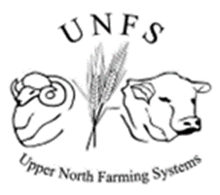

**Upper North Farming Systems**

**Report on Merino Flock Profiling Workshop**

**August 2024**

| Anne Collins  **AC Ag Consulting**  **PO Box 354 Quorn SA 5433**  Ph. 0427 486 115  [ACAgConsulting@bigpond.com](mailto:ACAgConsulting@bigpond.com) |  |  |  |
| --- | --- | --- | --- |

Prepared by:

**Report on Merino Flock Profiling Workshop**

Report prepared by Anne Collins, AC Ag Consulting

Information current as of 1st September 2024

© AC Ag Consulting 2024

All enquiries to the author.

Disclaimer

AC Ag Consulting does not warrant or make any representation regarding the use, or results of the use, of the information contained herein as regards to its correctness, accuracy, reliability and currency or otherwise. AC Ag Consulting expressly disclaims all liability or responsibility to any person using the information or advice.



Acknowledgement

The following contributed information and/or financial and logistical support to the running of this workshop:

Andrew Michael, Leahcim Poll Merino & White Suffolks

Rachel Trengove, UNFS

Predator Control and Productivity Network, funded by the Australian Government, MLA, PIRSA & Livestock SA

All of the producers involved





Table of Contents

1 Introduction 1

2 What is Merino Flock Profiling (MFP)? 1

3 2024 Workshop and Discussion of Results 2

3.1 Clarke Flock 2

3.2 Cleggett Flock 5

3.3 Combe Flock 6

3.4 Koch Flock 7

3.5 Kuerschner Flock 8

3.6 Nicholas Flock 9

3.7 Nutt Flock 10

3.8 Rodgers Flock 11

3.9 Smart Flock 12

4 Conclusion 13

**Tables**

Table 1: ASBV movements Clarke Flock 3

**Figures**

Figure 1: Clarke Flock MFP changes 2021-2024 3

Figure 2: Clarke Flock genetic trends 2020 to 2023 drop ewes 4

Figure 3: Cleggett Flock MFP changes 2021 to 2024 5

Figure 4: Combe Flock MFP changes 2021 to 2024 6

Figure 5: Koch Flock MFP changes 2021 to 2024 7

Figure 6: Kuerschner Flock MFP changes 2021 to 2024 8

Figure 7: Nicholas Flock MFP changes 2021 to 2024 9

Figure 8: Nutt Flock MFP changes 2021 to 2024 10

Figure 9: Rodgers Flock MFP changes 2021 to 2024 11

Figure 10: Smart Flock MFP changes 2021 to 2024 12

# Introduction

In 2021, a group of nine members of the Upper North Farming Systems group completed Merino Flock Profiles (MFP) together. Once all results were received, a workshop was held, delivered by Andrew Michael of Leahcim Poll Merino and Anne Collins of AC Ag Consulting. At this workshop, all the individual flock results were shared and each one discussed as a group. Also discussed was how to define a breeding objective, and there was a demonstration of the on-line RamSelect app. Each producer was able to go away with the genesis of a breeding objective for their own flock, and a plan for making better ram buying decisions having identified the traits they want to improve. As a result of the discussions, many were planning to place more focus on the carcase traits of fat & eye muscle diameter.

Following this workshop, some producers were happy to have it confirmed that they were on the right track with their existing breeding strategy; some felt they had greater confidence in talking to their ram source and outlining what they are looking for as a client; some were planning to have conversations with their ram source about their potential to start supplying ASBVs with sale rams; and others were even considering changing ram sources, so that they could make more informed ram buying decisions.

The same group of producers completed Merino Flock Profiles in 2024, three years after the initial testing. This is the suggested interval between tests, to enable producers to track any changes to their flock over time and to gauge whether the traits a flock is interested in are trending in the right direction. Another workshop was held where all the new MFP results were shared. This report discusses the changes that were observed with each flock.

# What is Merino Flock Profiling (MFP)?

A Merino Flock Profile allows commercial Merino flocks to benchmark their genetic potential relative to the entire Australian flock for certain Australian Sheep Breeding Values (ASBVs) and MERINOSELECT indexes. The MFP test provides flock average breeding values comparable to other flocks in the Sheep Genetics database. A flock can use the results to track genetic progress over time and help inform ram purchasing decisions.

Percentile bands are used to determine where your flock sits compared to all flocks in MERINOSELECT.

A score in the 10th percentile indicates your flock is in the top 10% of flocks for that trait.

Three MERINOSELECT indexes are also reported in the MFP. At the time of this workshop, the indexes reported in MFP and displayed in this report were the older indexes of Fibre Production (FP), Merino Production (MP) and Dual Purpose (DP). In 2024 these indexes have been replaced by four new indexes Fine Wool (FW), Wool Production (WP), Sustainable Merino (SM) and Merino Lamb (ML) and these new indexes will be reported in MFP results from September 2024. Two additional traits will also be reported, Reproduction (Weaning Rate) and Condition Score.

MFP testing involves taking a DNA sample from 20 randomly selected ewes from the youngest drop possible (ie. the most current genetics in the flock) and submitting these to a lab for genomic testing. The current cost is approximately $900.

More information is available here: <https://www.sheepgenetics.org.au/globalassets/sheep-genetics/getting-started/guide-to-flock-profile_2022.pdf>

It is always important to be aware that different production traits are correlated, and selecting for one trait may affect other traits. You may see an improvement in another trait (positive correlation) or a reduction (negative correlation). Useful information on key sheep production traits and their correlation can be found at the following link:

<https://www.pir.sa.gov.au/__data/assets/pdf_file/0008/386450/Sheep_Trait_Correlation_Fact_Sheet.pdf>

Included in the cost of a MFP test is one year’s subscription to the RamSelect on-line app. This app allows quick on-line searches of all rams listed for sale that align with a specific breeding objective. It also allows you to track the genetic merit of your ram team and also to track genetic gain in your flock as measured by your MFP results.

# 2024 Workshop and Discussion of Results

In June 2024 all participants in the original 2021 testing and workshop were contacted to gauge interest in repeating the MFP testing, three years down the track. There was overwhelming support, and all nine original participants completed a new round of testing.

In mid-August 2024, the group came together again to discuss and reflect on the results from this latest round of testing. This report presents, flock by flock, the changes that were observed over the three years and reflects on each individual producer’s learnings and plans for the future. Once again, the workshop discussion benefitted hugely from the contribution of Andrew Michael of Leahcim Poll Merino.

## Clarke Flock

Since the first MFP test and subsequent workshop, this flock has particularly focused on Eye Muscle Depth (EMD), Fat Depth (FAT) and Breech Wrinkle (EBWR) when selecting new rams for their sire team. They already had in mind that these were traits that they wanted to focus on, but the initial MFP test confirmed this as an appropriate strategy for this flock.

Looking at the table comparing the two years’ MFP results, it can be seen that the flock has made good gains with both EMD (ASBV moved from -0.1 to +0.2, flock percentile moved from 75 to 55) and FAT (- 0.5 to -0.2, percentile 80 to 60). Of note also is that the DCV (Fibre Diameter Coefficient of Variation) ASBV has decreased from +0.2 to -0.2. Reduced DCV is corelated with increased muscling and fat. Increased eye muscle depth and fat depth, as well as decreased coefficient of variation are all correlated with improved reproduction rates and number of lambs weaned. For more information on trait correlations see the link in section 2.

The flock has also improved its Early Breech Wrinkle (EBWR) score, moving from -0.2 to -0.3. Early breech wrinkle score is a good indicator of an animal’s susceptibility to breech strike. The lower the number the better. An EBWR ASBV of about -0.6 is a reasonable target for a flock that is looking to cease mulesing.

The producers are very happy with how the current lamb drop is looking visually and are happy with the trends over the three years for all the breeding values of significance to their breeding objective. They report that they are seeing improved lamb survival since making YFAT ASBV one of their main target traits. The scanning percentage for the flock has always been quite good but the ability to turn that into a good marking percentage has been increasing in the two years of joining rams with +ve YFAT figures.

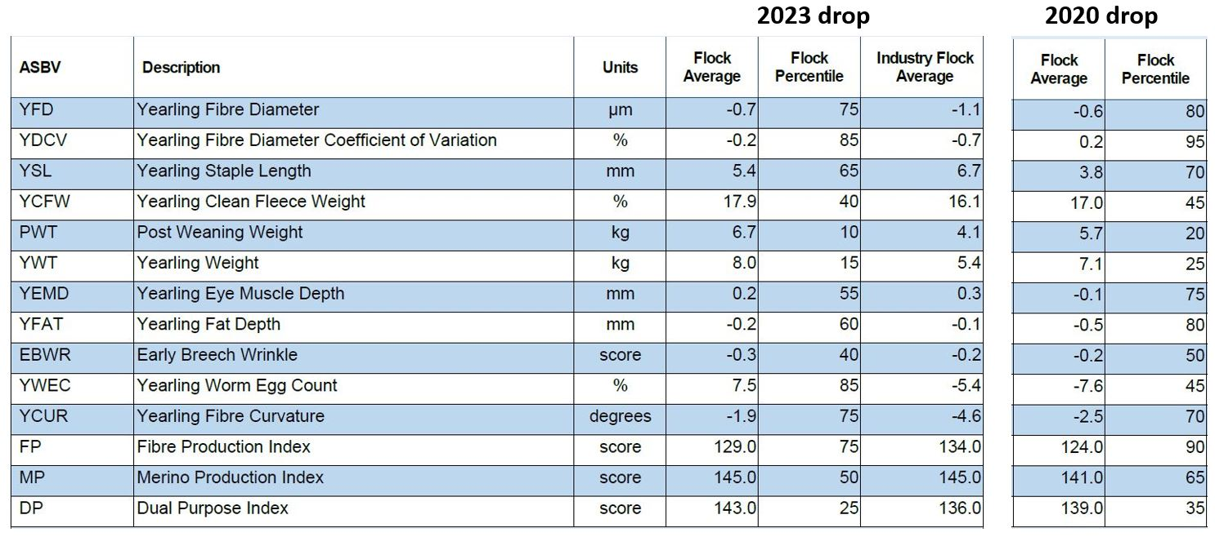

Figure : Clarke Flock MFP changes 2021-2024

Table : ASBV movements Clarke Flock

|  |  |  |
| --- | --- | --- |
|  | **ASBV** | **Observed change** |
| Fleece traits | YFD | Figure about right for this flock. Has trended more negative which is a move in the right direction, but not a key focus at this stage |
| YDCV | Reduced as discussed above; a good result |
| YSL | Has increased, which is also a move in the right direction. Is personal choice whether to focus on this trait. Ideally keep less than +12 if only want to shear once per year |
| YCFW | Has increased; top 40 percentile a good position to be in |
| Growth traits | PWT | Both growth traits have increased. This now in top 10 percentile |
| YWT | Moved from 25th to 15th percentile |
| Carcase traits | YEMD | An increase of 0.3 is a great result for a trait that is a key focus |
| YFAT | Also an increase of 0.3 a great result for a trait of focus; still plenty of opportunity to improve as now in 60th percentile |
| Welfare traits | EBWR | A decrease is a good result |
| YWEC | This has increased which is a move in the wrong direction but this trait is not of interest to this flock. |
| Index | MP | Most suitable index for this flock. Has moved from 65th percentile to 50th. |

This flock will continue to select for FAT, EMD and YDCV and look to hold other traits where they are, with the exception of continuing downward pressure on EBWR.

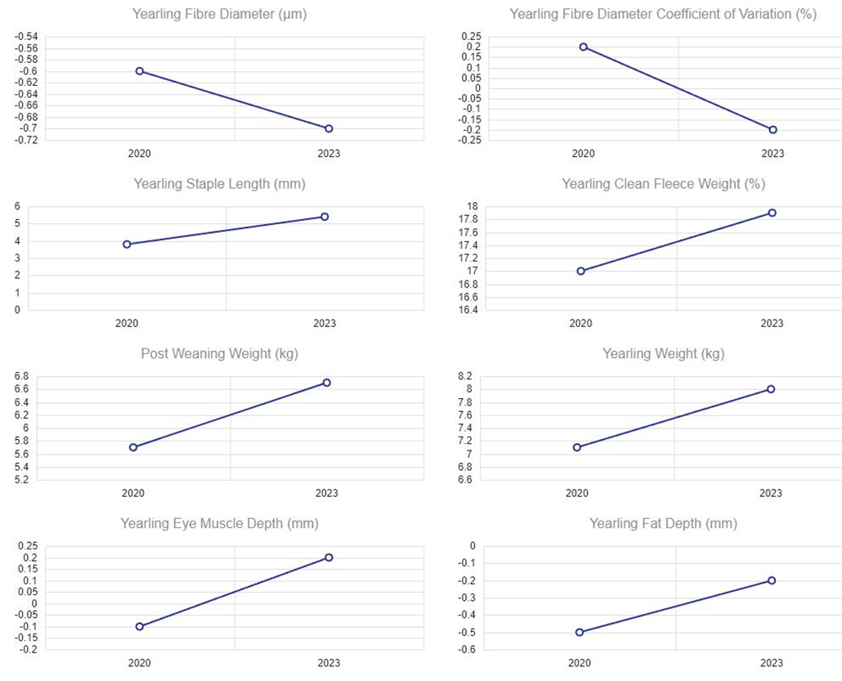

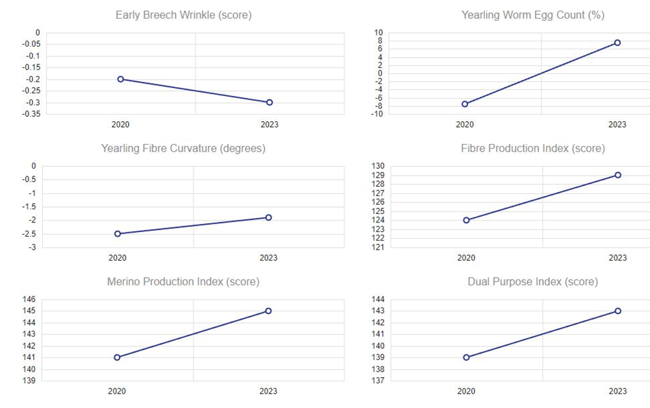

Figure : Clarke Flock genetic trends 2020 to 2023 drop ewes

All of these movements in trait values are illustrated in Figure 2, which are trend graphs for this flock downloaded from the RamSelect app. These are available for all the participating flocks, but only those for Flock 1 are included here by way of example.

The owners of this flock learned on the morning of the second workshop that their ram source was no longer going to supply any ASBVs on their sale rams. They had previously supplied within flock ASBVs and made them available to interested clients. Both generations from this business were present at the workshop and were very disappointed and at a loss as to what they would be doing moving forward. They had been happy with the rams they had been buying and the progress they were making towards their breeding objective. However, they were not happy at the prospect of buying rams ‘blind’ without the ASBV information, and considered that they may even need to change their ram source into the future.

Up until now the producers have found that, with a defined breeding objective and targets for certain ASBVs when buying rams, they have been able to purchase rams of high value to their flock, which may be at the bottom end of the sale, and thus avoided competing for the higher end “good looking” rams.

## Cleggett Flock

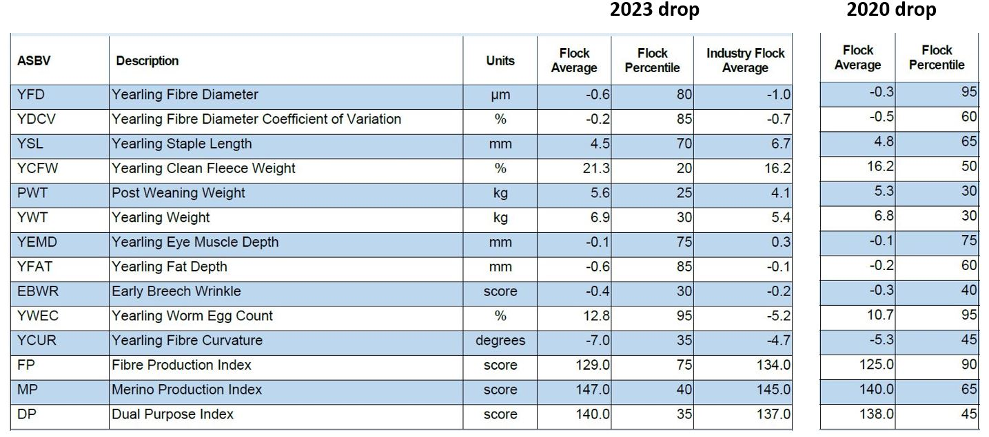

Figure : Cleggett Flock MFP changes 2021 to 2024

This flock’s take away message from the first MFP test and workshop was the value in focusing on muscle and fat traits, and the producer was keen to put significant focus on these traits when selecting replacement sires. However, EMD has not moved and the FAT ASBV has actually gone the wrong way by quite a bit. Helpfully, the YDCV has moved in the right direction.

Up until 2024, the stud this flock purchases sires from was only displaying raw data for each ram at sale. They have now made within flock ASBVs available to interested producers. Up until now this producer has made his purchasing decisions based on the individual animal measurements, but these measures do not allow the buyer to make adjustments for factors such as birth type, birth date, dam age and other environmental factors that can affect how an animal presents phenotypically.

The fleece weight for this flock is very good, in the top 20th percentile of all flocks in Australia, but sacrifices are currently being made with the carcase traits, which sit in the 75-85 percentile range.

The producer provided the observation that his rams often come in quite skinny at the end of mating and that he seems to be getting quite a few empties at pregnancy scanning.

Other options this flock will consider to try and improve the resilience related traits of FAT and EMD is to consider buying a small team of rams from a stud that provides across flock ASBVs, mating them separately and comparing the progeny, or actually genomic testing the existing ram team to help identify individuals that are superior in these traits.

This flock has quite a high Worm Egg Count (WEC) ASBV, in the 95th percentile. While this is not a key profit driver for this business, in the event of having access to ASBVs for this trait, it is worthy of paying some attention to, as it is known that animals with an improved resilience to worms also have improved immune function generally.

## Combe Flock

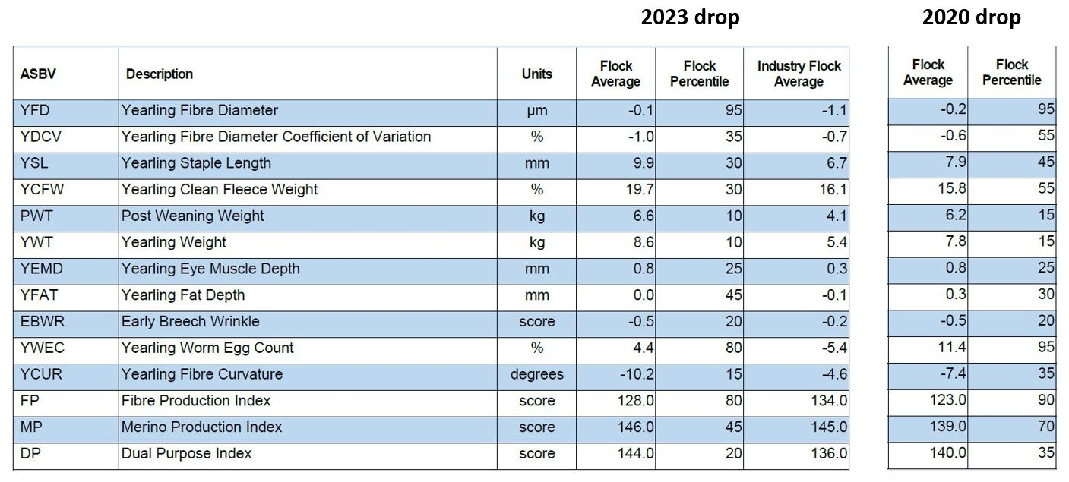

Figure : Combe Flock MFP changes 2021 to 2024

This flock has been breeding up from a SAMM base and so the wool is some of the strongest Merino wool in Australia, sitting in the 95th percentile for all flocks. This trait barely moved over the three years, and actually moved slightly stronger. The producer will continue to select rams to try and reduce YFD.

The staple length ASBV for this flock is in the 30th percentile. They have been shearing every 12 months but may try shearing more frequently. The staple length for last year’s clip was 130mm.

The EMD ASBV has stayed constant but is a good value, sitting in the 25th percentile. The fat depth ASBV has actually gone backwards, but the coefficient of variation has reduced which is a plus.

This flock has very high ASBVs for early growth, in the top 10% of all Australian flocks. Early growth is correlated to final adult weight, and this producer is keen to reduce his adult ewe weight from currently 85-100kg down to more like 70kg. Moving forward, he will endeavor to select rams with moderate yearling weight (YWT), while still maintaining the high PWT to give good early growth for early turn off and/or mating of ewe lambs.

## Koch Flock

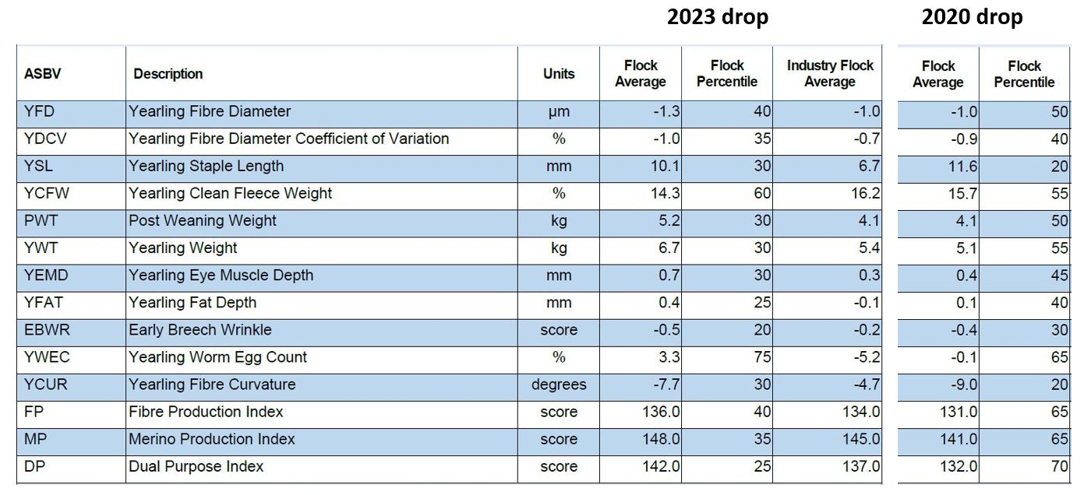

Figure : Koch Flock MFP changes 2021 to 2024

The figures for this flock are really well balanced, with nearly all traits sitting in the 40th percentile or higher. The take away message from the first MFP test and workshop was to focus on EMD and FAT when making ram buying decisions, which the owner has tried to do, with a view to increasing the numbers of lambs weaned. Both these traits have made good movement in the right direction and the producer reported an improvement in lambing rates over the three years.

The flock has historically been very focused on wool traits, but there is still opportunity to put some pressure on fleece weight. The flock is currently shearing every 12 months, but the staple length is getting over 120mm. The owner may consider shearing his younger ewes every 8 months and then 12 monthly as an older animal.

This producer’s ram source has provided ASBVs on all sale rams for some time. However, he was happy that, with his slightly adjusted ram buying strategy, he has still been able to buy the rams he wants for no more money than previously.

## Kuerschner Flock

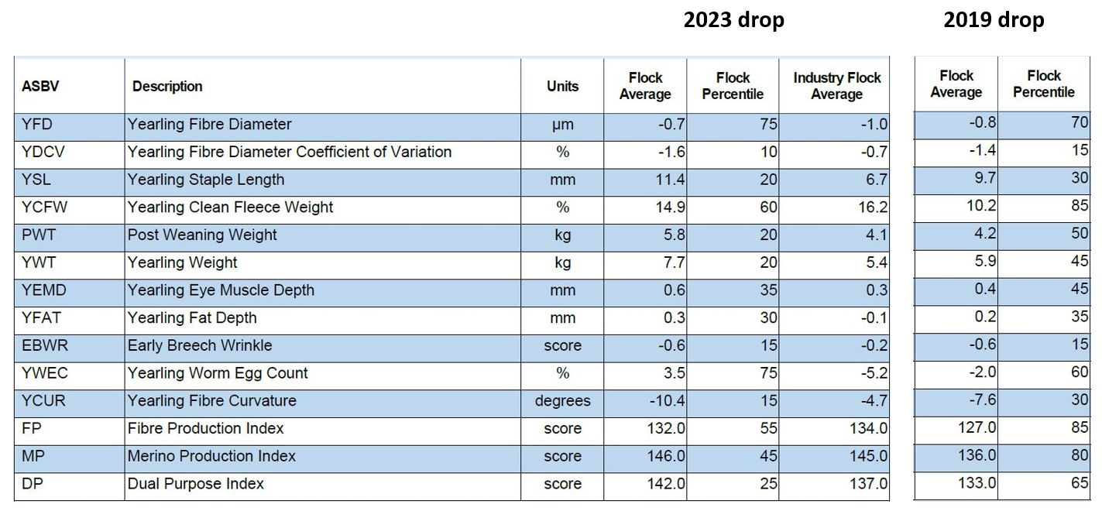

Figure : Kuerschner Flock MFP changes 2021 to 2024

The group of ewes that this flock tested at the first MFP test were a year older having already been classed, so were a biased representation of the whole flock. The second test on the 2023 drop ewes was taken prior to classing. Despite this, all the traits of interest have moved in the right direction. This flock has been sitting on -0.6 for EBWR for some time and the producer has not been mulesing for 17 years.

Most recently this flock has put more emphasis on fleece weight, but not at the expense of other traits. Fleece weight is one of the few traits currently sitting outside the top 35th percentile.

## Nicholas Flock

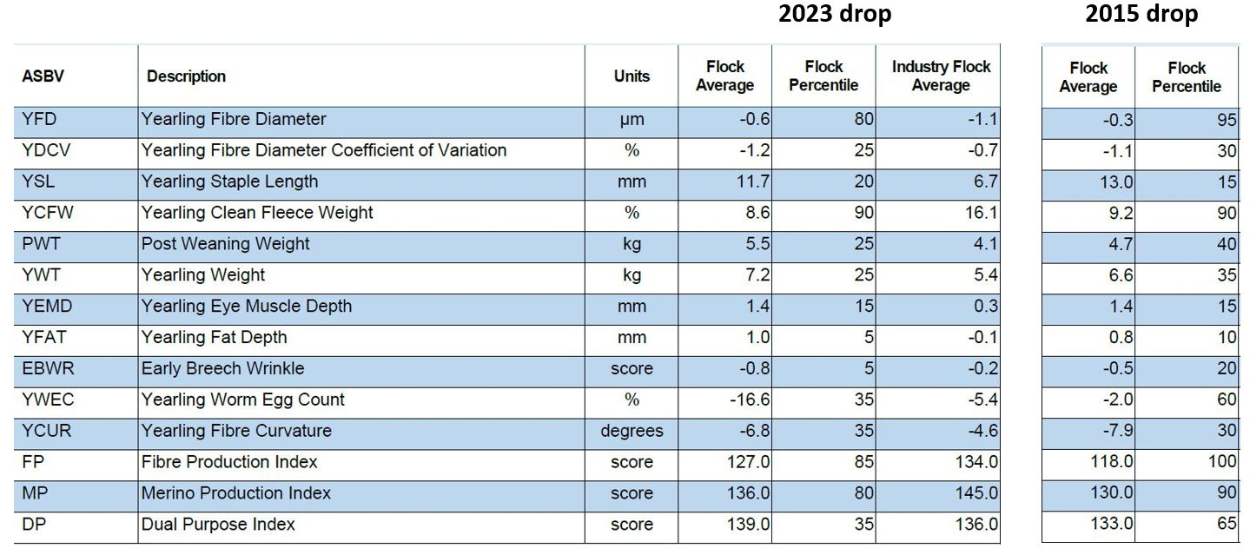

Figure : Nicholas Flock MFP changes 2021 to 2024

This flock is in a rebuilding phase. The ewes tested in the first MFP were a mob of bought in mature age ewes. Since this time, additional bought in ewes have been added to the flock. The producer focused on skin type when buying ewes which has had flow on benefits to EMD, FAT and EBWR traits. This is reflected in the most recent MFP results, with FAT and EMD sitting in the 5th and 10th percentile respectively.

The Early Breech Wrinkle (EBWR) in this flock is near one of the best in Australia, sitting in the top 5 percent of all Australian flocks and the producer has ceased mulesing. The WEC ASBV is also very good, and although not a trait of particular interest in this enterprise, it potentially means the sheep have an innately higher immune function.

The growth numbers in this flock are also good, and so this should be a highly fertile and well grown flock. This is reflected in the Dual Purpose Index value being in the 35th percentile.

The wool is the area where there is some opportunity for improvement in this flock, with fleece weight and fibre diameter having ASBVs in the 90th and 80th percentiles. The fibre diameter ASBV value could be another 1.5 micron lower, to better match the current fleece weight and return a higher value fleece. However, the producer has noticed an increase in carry capacity or stocking rates due to the ewes being able to maintain condition score due to them having very good genetic FAT. This overall has led to a higher wool cut per hectare, which somewhat compensates for the lower YCFW.

The staple length ASBV value at +11.7mm is the highest in the group and the producer has recently commenced six monthly shearing. Staple lengths have been 70mm and 64mm at the two six-monthly shearings so far. Generally speaking, a Staple Length ASBV of over 10 will lend itself to more frequent shearing.

## Nutt Flock

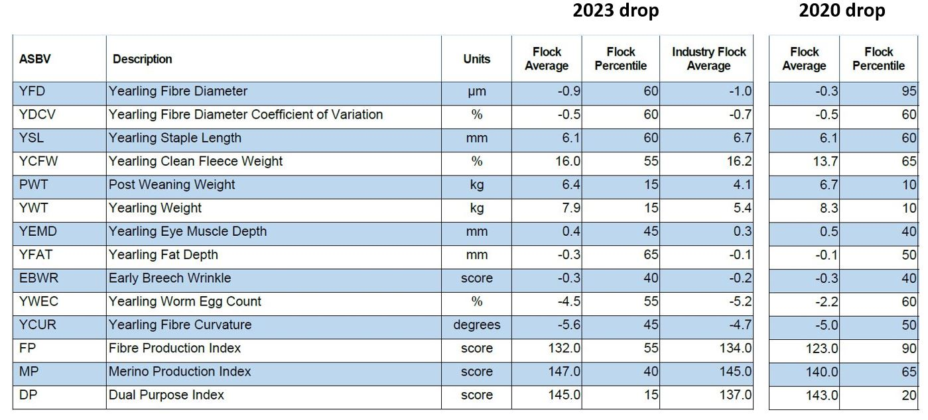

Figure : Nutt Flock MFP changes 2021 to 2024

For this flock, the take away from the first MFP test was to focus more on FAT and EBWR.

Where big gains have actually been made are in the fleece traits. Fibre diameter has significantly decreased while, at the same time, fleece weight has significantly increased. It is usually quite difficult to move these traits simultaneously like this as they are antagonistic to each other. The current fleece figures seem well balanced.

Further emphasis needs to be placed on the carcase traits, in particular FAT. Despite not moving these carcase traits in the right direction between the two tests, the flock has still made progress, evidenced by the improvement in the percentile bands of all indexes.

The owner has been buying rams using ASBVs but says he struggles with what he perceives as the very clean points of any of the rams that have high FAT ASBVs, and doesn’t want to compromise wool cut.

## Rodgers Flock

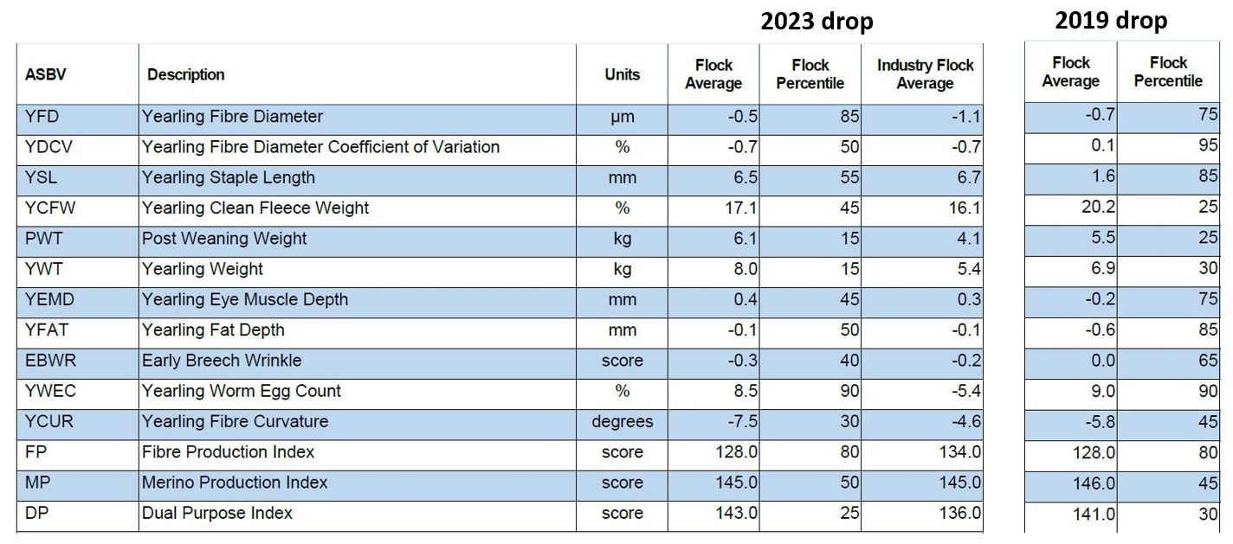

Figure : Rodgers Flock MFP changes 2021 to 2024

At the initial workshop this producer shared that one of the main challenges with his sheep enterprise was his number of lambs weaned. The results of his initial MFP lent some support to this observation, profiling animals that cut a lot of wool with good growth figures but being poor in the traits that correlate with reproduction such as FAT, EMD and DCV, which were in the 85th, 75th and 90th percentile respectively.

This producer decided, as a result of the initial MFP result and workshop, that he wanted to put more focus on EMD and FAT. His existing ram source was not supplying ASBVs with sale rams, and so he has begun sourcing rams from another stud that focuses on these traits in their breeding objective and supplies ASBVs with sale rams.

The sampling for the initial MFP provided a true representation of the average of the whole ewe flock at the time. In the first year the rams that were purchased from the new ram source were mated as a separate group to the existing ram team and with the use of eID in the progeny, these ‘first cross’ progeny were able to be identified. The second MFP sample was taken from this ‘first cross’ group, and therefore is not a true representation of the entire ewe flock. This does however provide good insight into the impact of these new genetics.

There have been significant improvements in all of the key traits that the producer was concerned with, namely EMD, FAT and YDCV. All of these traits have moved at least 30 percentile points, including a massive improvement in the YDCV from +0.1 to -0.7, moving from the 90th percentile to the 50th percentile. The movement in all these traits together is a good illustration of the correlation between these traits.

The producer reported that he was very happy with the lambs from these rams, saying they appear “fresher and better looking”. He also reported an apparent improvement in pregnancy scanning results, with recent results of 55% twins and 18% empties.

The 0.6mm increase in the EMD ASBV should result in around a 1.5% increase in dressing percentage for progeny from this flock. Low dressing percentages were also identified by the producer as something he would like to address.

The Staple Length figure has also increased significantly, from the 85th percentile to the 55th percentile.

There have also been slightly more moderate improvements in the growth rate ASBVs and in the Early Breech Wrinkle score.

This producer has assessed that currently the breakdown of income from his flock is 60:40 meat:wool, hence his interest in placing more emphasis on the traits that will improve number of lambs weaned and growth and dressing percentage of progeny.

## Smart Flock

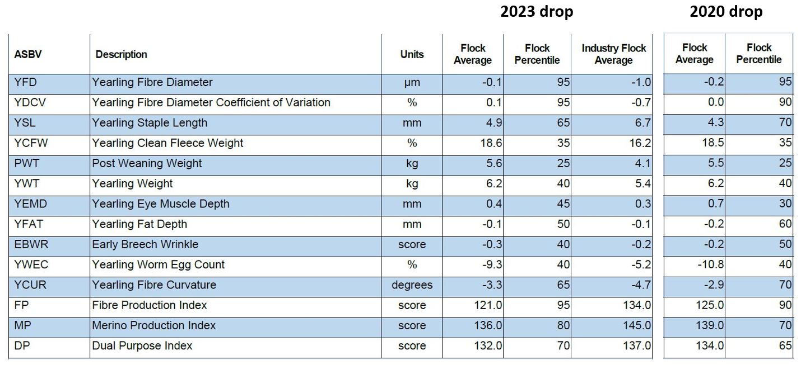

Figure : Smart Flock MFP changes 2021 to 2024

This producer has not made any significant changes to his ram buying decisions as a result of the first MFP, but instead has relied on his stud making the genetic gains for him. The ram source does not publish ASBVs and there has been very little change in this flock’s ASBV values over the three-year period.

The most attractive trait in this flock is the good early growth (PWT). The Coefficient of Variation figure is very high, sitting in the bottom 5% of all Australian flocks. This number could probably be shifted in the right direction by selecting for this visually or on raw data.

The producer would like to put more selection on increasing fat cover within his own flock, and will make this a priority including condition scoring all ewe hoggets and making culling decisions based on this. There is also opportunity to move the fat ASBV in the right direction, should ASBVs become available for ram selection.

# Conclusion

The format adopted in this project has proved to be an excellent approach for wool grower learning and adoption of the use of ASBVs in formulating breeding objectives and in Merino ram buying decisions.

Producers were able to improve their understanding of ASBVs and industry indexes; benchmark their flock against the Australian Merino flock; identify individual traits that present opportunities for flock improvement; formulate an individual breeding objective; make ram buying decisions based on these objectives; and observe the impact of these decisions on their flock’s genetic potential over a three-year period.

Nearly all of the producers in this group are mixed farmers, and one of the participants provided the following analogy, “In our cropping enterprises we wouldn’t make fertilizer decisions without doing a soil test every few years. The MFP is the equivalent of a soil test for your Merino flock. And we wouldn’t change varieties without looking at the National Variety Trial results first, which is the equivalent of using ASBVs to make genetic decisions in the flock.”

This project is potentially a useful model for other producer groups who want to become familiar with Australian Sheep Breeding Values and how they can be a useful tool for making genetic progress in their flocks.