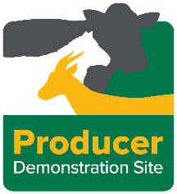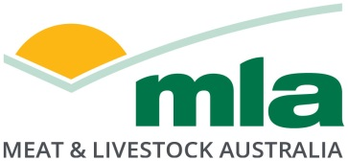

Final report

PDS Improved Pasture Management Systems

Project code: L.PDS.2201
Prepared by: Rachel Trengove
Upper North Farming Systems

Date published: 10 April 2026

PUBLISHED BY
Meat & Livestock Australia Limited
PO Box 1961
NORTH SYDNEY NSW 2059

Meat & Livestock Australia acknowledges the matching funds provided by the Australian Government to support the research and development detailed in this publication.
This publication is published by Meat & Livestock Australia Limited ABN 39 081 678 364 (MLA). Care is taken to ensure the accuracy of the information contained in this publication. However MLA cannot accept responsibility for the accuracy or completeness of the information or opinions contained in the publication. You should make your own enquiries before making decisions concerning your interests. Reproduction in whole or in part of this publication is prohibited without prior written consent of MLA.

Abstract

This Producer Demonstration Site (PDS) project, delivered by Upper North Farming Systems with support from Meat & Livestock Australia, investigated the performance and practicality of mixed-species pastures compared with traditional monoculture systems in low–medium rainfall mixed farming systems of South Australia’s Upper North. The project aimed to assess impacts on livestock performance, pasture biomass, groundcover retention and producer capability, while also demonstrating the use of satellite-based pasture monitoring tools to support feed budgeting and grazing decisions.

Demonstration sites were established between 2022 and 2025, with usable results obtained in the 2022 and 2023 seasons. Findings showed that mixed-species pastures can establish successfully and support livestock production under favourable conditions, with sheep performance influenced more by pasture composition, quality and sowing rates than species diversity alone. Satellite imagery showed correlation with ground-measured biomass, particularly in drier feed conditions, and proved most effective when combined with ground-truthing, pasture assessments and feed testing.

Seasonal conditions, including drought and site management disruptions, limited multi-year data collection and prevented a robust economic analysis and quantitative assessment of adoption. Nevertheless, the project successfully improved producer knowledge and skills through targeted extension activities, increased confidence in feed budgeting practices, and provided practical insights to support more resilient, sustainable grazing systems in highly variable climatic environments

Executive summary
Background
This Producer Demonstration Site (PDS) project was delivered by Upper North Farming Systems with support from Meat & Livestock Australia. The project addressed the on-farm challenge of improving pasture productivity, livestock performance and groundcover retention in low–medium rainfall mixed farming systems of South Australia’s Upper North, where seasonal variability and drought significantly limit feed reliability.
The primary target audience was mixed enterprise sheep producers operating in variable and low rainfall environments who are seeking practical, evidence-based strategies to improve grazing management and enterprise resilience. Results from the demonstration were intended to inform pasture establishment decisions, grazing management, feed budgeting practices and adoption of satellite-based monitoring technologies.
Objectives
The project aimed to:
- Demonstrate the performance of mixed-species pastures compared with traditional monocultures under commercial farm conditions.
- Evaluate livestock production, pasture biomass and groundcover outcomes.
- Demonstrate the application of satellite imagery for estimating Feed on Offer (FOO).
- Build producer knowledge and confidence in pasture assessment and feed budgeting.
While seasonal conditions limited multi-year comparisons and economic analysis, the majority of demonstration and extension objectives were achieved, particularly in building producer capability.
Methodology
Paired paddock demonstrations were conducted in 2022 and 2023 to compare single-species and mixed-species pastures under similar conditions. Measurements included biomass cuts, pasture composition, feed quality (NIR), and sheep liveweight gain and condition score. Satellite imagery (CiboLabs) was used to estimate biomass and groundcover and was validated through ground-truthing, with outputs integrated into AgriWebb to support feed budgeting.
Producers worked alongside a livestock consultant to guide pasture selection, grazing management and interpretation of results, ensuring the demonstrations remained practical and relevant.
Extension activities, including workshops, field days and training sessions, were designed to build producer skills and confidence. These provided opportunities to engage with experts and peers, with a focus on practical skills such as pasture assessment, condition scoring and feed budgeting.
Results / Key Findings
Demonstration outcomes:
Mixed-species pastures successfully established in favourable seasons and supported livestock production.
Sheep liveweight gain was influenced more by pasture composition, quality and sowing rate than species diversity alone.
Satellite imagery correlated with measured biomass, , but was less reliable in predicting pasture composition and quality.
Strong correlation between satellite data and biomass in dry feed conditions, but reduced accuracy in early/lush growth.
Cost:benefit / economic evaluation:
Seasonal conditions and site management disruptions prevented robust economic analysis and full cost:benefit evaluation.
Extension and communication:Six extension activities and multiple communications reached over 250 Upper North producers, improving knowledge and confidence of pasture assessment, feed budgeting and the strengths and limitations of satellite monitoring tools.
Monitoring and evaluation:
Seasonal variability significantly affected demonstration continuity and data completeness and therefore formal monitoring & evaluation of the project was limited.
Benefits to Industry
The project provides practical, regionally relevant insights into pasture diversity, grazing management and remote monitoring technologies for low rainfall systems. It strengthened producer capability in feed budgeting and pasture assessment, supporting more informed decision-making and improved resilience under variable climatic conditions.
Future Research and Recommendations
Future research should focus on multi-season evaluation of mixed-species systems under drought conditions and more robust economic analysis.
Further development of satellite and drone technologies to better assess pasture composition and quality would improve decision-support tools.
Ongoing extension support is recommended to maintain adoption momentum and reinforce practical feed budgeting skills among producers.

Table of contents

Abstract 2
Executive summary 3
1. Background 7
1.1 Upper North Farming Systems 7
1.2 Improved Pasture Management Systems 7
2. Objectives 8
3. Demonstration Site Design 10
3.1 Methodology 10
3.2 Economic analysis 13
3.3 Extension and communication 13
3.4 Monitoring and evaluation 14
4. Results 15
4.1 Demonstration site results 15
4.2 Economic analysis 25
4.3 Extension and communication 26
4.4 Monitoring and evaluation 29
4.4.1 Pre-project surveys 29
4.4.2 Post -project surveys 30
5. Conclusion 30
5.1 Key Findings 31
5.2 Benefits to industry 31
6.References 33
7. Appendix 34
7.1 Monitoring and evaluation plan 35
7.2 Pre Project survey templates 39
7.3 Post project survey template 48
7.4 Summary of post project survey results 53
7.5 Communication plan 55
7.6 Producer Case Study 59
7.7 Newsletter articles 60

Background

Upper North Farming Systems
Formed in 2001, the Upper North Farming Systems (UNFS) group conducts research and development trials and provides extension and networking opportunities for farmers, agronomists, researchers and other primary industry participants. UNFS covers a diverse geographical area in the Upper North region of South Australia, bordered to the north and east by the pastoral zones and extending south to the higher rainfall zones, and encompasses the towns of Booleroo Centre, Crystal Brook, Hallett, Jamestown, Laura, Peterborough, Nelshaby, Orroroo, Quorn and Wilmington. It’s 250 members have a range of enterprises, dominated by cereal-sheep-legume rotations. Members are committed to improving enterprise sustainability, profitability, and viability in a low-medium rainfall environment. UNFS is managed by three part time staff, a Strategic Board of 10 and an operations committee of 22. UNFS have a Strategic Plan, Policies and Procedures for project, financial and communication management. The group partners with commercial and private agronomists, livestock consultants and natural resource managers to identify and deliver appropriate and effective projects across the region in all aspects of agriculture. Projects and reports are available on the website www.unfs.com.au.

Improved Pasture Management Systems
Mixed farming systems dominate the Upper North Agricultural Zone of South Australia, with more than 85% of producers operating integrated cropping–livestock enterprises. A key challenge within this system is balancing the pasture phase requirements for livestock productivity while maintaining soil fertility, groundcover and rotational benefits for subsequent cropping. Currently, the pasture phase is typically based on monocultures of annual legumes such as medic or vetch, selected primarily to provide a grass-free break crop and nitrogen fixation ahead of cereals. While effective for nitrogen contribution, monoculture pastures present several well-documented limitations, including animal health risks (such as red gut, bloat, pulpy kidney and cowpea aphid toxicity), slow winter establishment under cold conditions, and limited biomass production and residue retention. These constraints can result in reduced feed availability, increased animal health interventions, and greater susceptibility of soils to erosion during summer fallow periods. In contrast, diversified agricultural systems have been shown to sustain both crop and livestock production while delivering additional ecosystem services, including improved soil carbon storage, more efficient nutrient cycling and enhanced biodiversity (Sanderson et al., 2013). Despite this evidence, there remains a significant knowledge gap regarding the performance and practicality of mixed sown pastures under Upper North conditions.
This project sought to address this gap by demonstrating mixed sown pasture systems under local conditions and comparing their performance with traditional monoculture pastures. The primary question being addressed was whether mixed species pastures could provide equal or greater food on offer (FOO) and animal performance while also improving soil cover. A secondary issue was the low adoption of feed budgeting and pasture assessment practices, despite growing recognition of their value. With limited labour availability on most farms, producers have identified the need for practical and time-efficient tools to assess FOO, pasture quality and grazing decisions. The target audience for this project was mixed-farming producers in the Upper North region, particularly those reliant on annual legume monocultures and those not currently using feed budgeting or pasture monitoring tools (estimated adoption of 10–20%). Observations and results from this demonstration were used to support extension activities, improve producer confidence in mixed sown pasture systems, and encourage wider adoption of pasture monitoring tools on farm.

Objectives
- By January 2026, in the Upper North region of South Australia:

Demonstrate three options for a mix of pasture/fodder species that can provide superior FOO measured by:
a. Improved liveweight growth of sheep
b. Improved CS of sheep
c. Improved biomass production
d. Improved ground cover

This objective was partially achieved.

During the 2022 and 2023 seasons, all indicators listed above were demonstrated and measured. The pasture and fodder mixes established well, allowing for assessment of sheep performance, biomass production and ground cover, and demonstrating the potential of these systems under favourable seasonal conditions.

However, the objective could not be fully achieved across the entire project timeframe due to significant external constraints. In 2024, a severe drought resulted in failure of pasture germination, preventing data collection. In 2025, the demonstration site was compromised when sheep trampled the electric fencing between treatments, and the landholder subsequently elected to take the site through to grain production (barley sown in both single and mixed treatments) following late seasonal rains, driven by surplus feed and strong economic returns from cropping.

Despite these challenges, the project demonstrated the intended outcomes in suitable seasons and provided valuable insights into pasture performance and system flexibility under typically variable and challenging climatic conditions typical of the Upper North region.

2. Conduct an analysis of the cost:benefit of the trialled pasture mixes

This objective was not achieved. As discussed with Alana and Russell (MLA), the limited and incomplete data collected over the project period (due to seasonal conditions and site disruptions outlined above) did not provide a robust or reliable basis on which to undertake a meaningful cost–benefit analysis. Proceeding with such an analysis under these circumstances would not have delivered credible or defensible results.

3. Adoption:
a. 60% of core/engaged producers will have adopted improved pasture mixes that have resulted in either an improved biomass production by 10% or groundcover over summer by 5% depending on the pasture mix and site objectives.
b. 10% of observers (measured from workshop and field day participants) will have adopted improved pasture mixes that have resulted in either an improved biomass production by 10% or groundcover over summer by 5% depending on the pasture mix and site objectives.

Only four post-project surveys were received, which does not constitute a representative sample for meaningful analysis of adoption outcomes across either core/engaged producers or observers. As a result, adoption rates and on-farm impacts could not be reliably quantified against the original targets.

In addition, the project was significantly impacted by two failed seasons beyond the control of the project manager. These seasonal conditions meant the project could not be completed as originally planned, and it is unlikely that sound or defensible conclusions could be drawn from post-survey results alone.

Following the 2024 drought, several participating producers significantly reduced livestock numbers or exited sheep production entirely, further limiting both the opportunity and relevance for pasture adoption and measurement of outcomes through post-surveys.

Survey results and a high-level summary of responses are included in the Appendix; however, they have not been further analysed or interpreted due to the limitations outlined above.

4. Awareness, Knowledge and Skills:

a. 100% of core/engaged producers will have an improved understanding of pasture mixes, the role they play in improved biomass production and maintaining groundcover over summer and how to measure and manage them to improve livestock production outcomes.

b. 50% of observers (measured from workshop and field day participants) will have improved understanding of pasture mixes, the role they play in improved biomass production and maintaining groundcover over summer and how to measure and manage them to improve livestock production outcomes.

As above

5. Conduct ground truthing for CiboLabs at 1 site in the region on at least 2 different pasture types (1 sown mixed pastures (demonstrations), 1 single species or self-regenerating pasture (control)).

Ground truthing was conducted for CiboLabs at Henderson’s site for both mixed and single species pastures for two consecutive years (2022 & 2023). Measurements were collected using the CiboLabs Survey123 app which involved collecting on-the-ground observations to validate and refine satellite-derived information. Field data, including crop type, growth stage and ground cover were recorded directly in the app and linked to precise GPS locations. Biomass cuts were undertaken, with dry matter (DM) measured and entered into the app. This real-world data was then used to confirm the accuracy of satellite imagery outputs, improve model calibration, and increase confidence in the insights generated by CiboLabs for ongoing monitoring and decision-making.

6. Demonstrate the use of satellite pasture monitoring technology for feed budgeting and encourage adoption of the new technology by 3 producers.

The use of satellite pasture monitoring technology has been demonstrated by using CiboLabs subscription to monitor paddocks over the growing season – imagery was captured pre-graze, post graze and a 1 month recovery period post grazing. Farm Map4D was originally planned to also provide satellite imagery data, however the company folded after the project started so imagery was only derived from CiboLabs in this report.

7. Implement a series of training activities to increase producer understanding of assessing FOO and feed budgeting and encourage adoption of these practices by 25 producers.

This objective was successfully achieved. A range of extension and training activities were delivered throughout the life of the project, as outlined in Section 3.3 Extension and Communication. These activities increased producer understanding of assessing FOO and feed budgeting through a combination of technical presentations, peer-to-peer learning from demonstration site landholders, and the ongoing distribution of project results. This integrated approach supported knowledge transfer, practice change, and encouraged adoption of FOO assessment and feed budgeting practices among participating producers.

Demonstration Site Design

3.1 Methodology
Producers involved in this project were selected through an Expression of Interest process facilitated by the UNFS Operations Committee, which also served as the Project Delivery Steering Committee. Following assessment of expressions of interest, participating producers and demonstration sites were endorsed at an UNFS Operations Committee meeting.

At project commencement in 2022, three demonstration sites were selected and established. In 2023, suitable sites became increasingly difficult to secure due to the complexity of the demonstration site management. Following discussions and negotiations with Meat & Livestock Australia (MLA) project managers, a formal variation to the contract was approved, allowing the project to continue with a single demonstration site for the remaining two years of the project.

The site locations and details are shown in Table 1.

Table 1: PDS paired site locations, rainfall and pasture species.

Year | Location | Latitude (decimal degrees) | Longitude (decimal degrees) | Single species pasture | Mixed species pasture | Actual Rainfall (mm)
2022 | Caltowie Nth | -33.109862 | 138.455904 | Vetch | Vetch/Barley | 489
2022 | Melrose | -32.8054010 | 138.1918460 | Vetch | Vetch/Oats | 584
2022 | Pekina | -32.7741940 | 138.4572240 | Vetch | Vetch/Wheat/Canola | 427
2023 | Caltowie Nth | -33.109862 | 138.455904 | Forage Brassica | Forage Brassica/Vetch/Barley | 282
2024 | Caltowie Nth | -33.109862 | 138.455904 | Forage Brassica | Forage Brassica/Vetch/Barley | 211
2025 | Caltowie Nth | -33.109862 | 138.455904 | Barley | Barley/Vetch/Forage Brassica | 285

Figure 1. Map of locations – Upper North, SA.
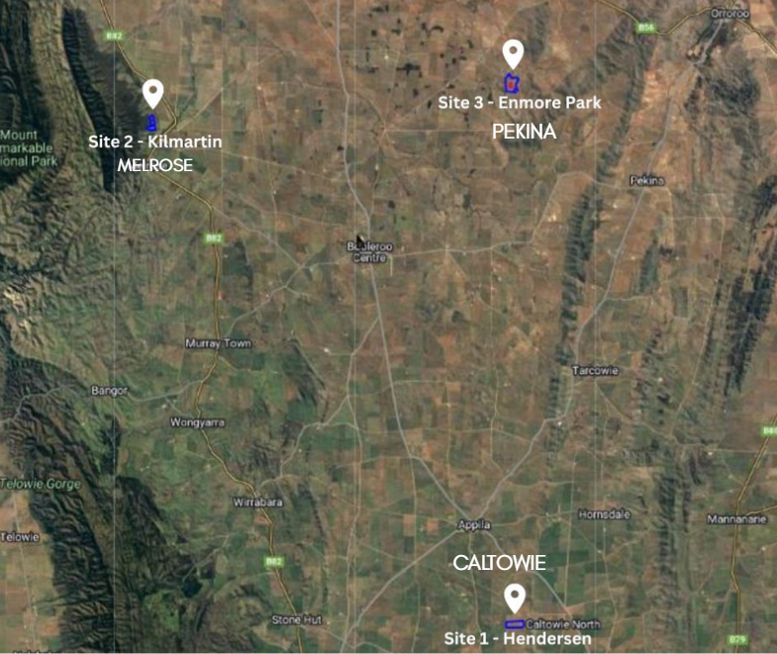

All producers worked alongside a livestock consultant to guide implementation of PDS demonstration practices including pasture species selection.

Demonstration
Pasture species mixes were trialled including measures of biomass and animal performance at 3 sites in 2022 and 1 site for the remainder of the project term. Performance was compared for the sown mixed pasture (demonstration) with the traditional monoculture or self-regenerating pasture (control). The sites comprised of one large paddock split into 2 (to ensure paddock history is comparable). Each paddock was greater than 10ha in size. Each pair sown with the same seeder, sowing time and treated with same fertilizer regime. Seed was supplied by the local farmer. Grazing of paired sites occurred at the same time with similar grazing pressure from a split mob. A pre-grazing final ground cover level and/or sheep condition was stipulated and when one of the two paired sites/mobs reached this, both sites ceased to be grazed.

Treatments
2022
Single species: Vetch
Mixed Species: Vetch/Barley
(no rates recorded)

2023
Single species: Sub zero @ 5kg/ha
Mixed Species: Barley @ 65kg/ha, Vetch @ 40kg/ha, Sub zero @ 2kg/ha

2024
Drought - Failed germination – no results

2025
Single species: Barley @ 75kg/ha
Mixed Species: Barley @ 70kg/ha, Vetch @ 30kg/ha, Sub zero @ 3kg/ha

Assessments included:
- Animals weighed in and out.
- Animals CS in and out.
- Pasture composition, groundcover, biomass and feed quality (Feed Test NIR Fodder Package for each of the pasture species) in-field assessment pre & post grazing including a recovery assessment 2 months post grazing.
- Remote monitoring of biomass/FOO and groundcover pre and post grazing (incl recovery rate) and biomass sampling and use of CiboLabs Survey 123 App to ground truth satellite imagery.
- Cibo Labs data was linked to AgriWebb App as a grazing prediction tool.

In Season Measurements:
Biomass Cuts
Biomass was sampled before grazing, after grazing and one-month post-grazing.
Two locations were randomly identified for each treatment, with GPS locations recorded and used for consecutive cuts.
Five 50 x 50 cm quadrants were placed ten steps apart at each site, biomass from inside the quadrant was cut and added to a paper bag. Samples were weighed before being dried at 60 degrees for 24 hours. Samples were then re-weighed to get a dry matter value. These values were then used to calculate total dry matter per hectare.
Each quadrant location was photographed.

Pasture Composition
Pasture composition was recorded before grazing, after grazing and one-month post-grazing at the same time biomass cuts were taken.
At each biomass sampling site (50 x 50 cm quadrant), pasture composition was recorded using the following categories;
-Grass weeds (for example silver grass, wild oats, barley grass)
-Broadleaf weeds (geranium, cape weed, salvation jane)
-Cereal (Barley, oats)
-Pasture legumes (vetch, clover, medic)
-Bare ground

Feed Tests
A representative sample of each treatment was collected from biomass samples and sent to AgriFood Technology for analysis.

Sheep Weights and Condition Scores
Ewe hoggets were used in this trial to obtain weight gain values.
They were weighed and condition scored prior to being put onto the two treatments. They then grazed the pasture for a period of one month, before being taken off the pasture and re-weighed and condition scored.

Satellite Imagery
Paddock boundaries were added into CIBO software to collect satellite imagery for the duration of this project.

Interpretation of NDVI map colour -
Biomass based maps - Typically BLUE indicates a higher density biomass or thicker canopy. RED indicates less biomass or a thinner canopy

3.2 Economic analysis
No economic evaluation of this PDS was conducted – as explained in 2.2 Objectives.

Extension and communication
The extension and communication activities were designed to enable producers to learn from the PDS project. Sessions were designed to suit producer needs providing opportunities to engage with livestock technical experts and researchers, practice practical skills, as well as engaging in peer-to-peer learning.
Activities undertaken included:
Field days / paddock walks (min. annually)
Three Field Days were held at pasture demonstration sites, attended by core producers plus open to all. At least once in the project, this was part of the UNFS Annual Members Expo where 100+ producers attended.
Workshop/s
Three workshops, with dates set to maximise attendance by core producers but open to all to attend where capacity allows were held. Workshop topics included:
• Training workshop with satellite monitoring service provider.
• Training in pasture sampling and assessment suited to ground truthing the satellite images.
• Training in feed budgeting, FOO, pasture planning.
Extension activities were promoted to the wider group through already established UNFS communication strategies open to anyone to attend.
Video/s
Where appropriate field day and workshop content was videoed and these were used for short course content and awareness raising. A short video will be put together with an overview of the project, its aims and the summary of the first 1-2 years’ outcomes.
In depth articles
Published annually in the UNFS Annual Compendium and made available to all interested parties (farming systems groups, funding bodies, research partners) for re-publication/sharing with their networks.
Case studies
One case study was produced (included as an Appendix)
Social and traditional media articles and segments were produced throughout the project in relation to demonstration sites, workshop content and case study outcomes.
All training workshops and field days were organised by Rachel Trengove, PDS Facilitator, and delivered in collaboration with recognised industry experts in pasture species, feed budgeting, remote sensing, FOO assessment tools, pasture quality and grazing decision-making. All sessions were open to all producers.
Several activities were delivered in partnership with organisations including the SA Drought Hub and the Northern and Yorke Landscape Board. These collaborations provided additional funding for guest speakers and helped ensure strong producer attendance by reducing duplication of livestock extension activities across the Upper North region.

Monitoring and evaluation
Producers were surveyed at the commencement and completion of the project.
Entrance surveys were developed and conducted with core producers to:
• benchmark current knowledge and skills
• collect data on producer numbers and animals, and area potentially impacted by the project
• establish pasture management & FOO knowledge and current adoption of the practices demonstrated in the PDS
Exit surveys were conducted by core producers to enable assessment of changes in:
• reactions (perceptions, enthusiasm etc.) as a result of the project
• knowledge, attitudes, skills and aspirations
• adoption of practices
Demonstration site success was measured by changes in the following parameters when comparing the mixed pasture species to the monoculture:
- Increased lamb growth rates
- Improved ewe condition score (CS)
- Increased biomass production
- Improved ground cover
Core working group success was measured quantitatively by changes in producer experience and attitude to multi species pastures, pasture monitoring and feed budgeting and their willingness to incorporate these into their farming system.
Broader industry awareness and adoption was measured by :
a) Changes in producers’ knowledge and adoption of remote pasture monitoring
b) Changes in producers’ confidence to assess FOO and the use of feed budgeting

Results

4.1 Demonstration site results
Results presented in this report relate to the Henderson’s demonstration site located at Caltowie only, and only for the 2022 and 2023 seasons.

Prior to the approved variation to the PDS contract reducing the project to a single demonstration site, two additional sites were established in 2022 (Melrose and Pekina). However, both sites experienced significant issues that compromised the integrity of the results.

At the Melrose site, ewes were unexpectedly pregnant and lambing commenced midway through the grazing period. This rendered sheep liveweight measurements invalid and prevented meaningful comparison between treatments.

At the Pekina site, weed pressure was dominant across the trial area, making it difficult to clearly differentiate between pasture treatments. As a result, outcomes were incomplete and conclusions could not be confidently drawn from these sites.

No results were obtained from the Henderson’s site in 2024 or 2025. In 2024, a severe drought resulted in complete pasture germination failure, preventing data collection. In 2025, the demonstration site was compromised when sheep trampled electric fencing and dispersed between treatments part way through the grazing period, after pre-grazing measurements were done. Following late seasonal rainfall, the landholder elected to transition the site to grain production (barley sown in both single and mixed treatments), influenced by surplus feed availability and strong economic returns from cropping.

These seasonal and management factors were beyond the control of the project manager and significantly limited the ability to generate a complete multi-year dataset.

Table 2. Summary of sheep weight gain results 2022 and 2023 – Caltowie North (Henderson’s) grazing site.
 | Av Pre Graze Weight | Av Post Graze Weight | Av Post Graze CS | Av Weight gain
2022
Mixed Species | 47.47 | 55.4 | 3.49 | 7.93
Single Species | 46.2 | 50.01 | 3.44 | 3.81
2023
Mixed Species | 40.17 | 48.95 | 3.46 | 8.78
Single Species | 41.01 | 51.25 | 3.48 | 10.24

Table 3. Summary of feed test results – 2022, 2023 and pre-graze 2025 before fence dividing treatments was trampled.

2022 | Vetch |  |  | Vetch/Barley
 | Pre-Graze | Post Graze | 1 Month Recovery | Pre-Graze | Post Graze | 1 Month Recovery
Dry Matter (%) | 26.3 | 16.3 | 17.4 | 40.4 | 22.9 | 25.8
Digestibility (% of dry matter) | 62.3 | 71 | 63.1 | 50.5 | 65.8 | 63.2
Metabolizable Energy (MJ/kg DM) | 9.1 | 10.6 | 9.2 | 7.1 | 9.7 | 9.3
Protein | 23.6 | 28 | 21.4 | 12.2 | 18.3 | 14.7
2023 | Forage Brassica |  |  | Barley/Vetch/Forage Brassica
 | Pre-Graze | Post Graze | 1 Month Recovery | Pre-Graze | Post Graze | 1 Month Recovery
Dry Matter (%) | 16.7 | 55.7 | 89.8 | 20.2 | 50.6 | 89.5
Digestibility (% of dry matter) | 76.3 | 61.8 | 55.5 | 73.4 | 62 | 58.3
Metabolizable Energy (MJ/kg DM) | 12.5 | 9.5 | 8.3 | 11.9 | 9.6 | 8.8
Protein | 20 | 11.5 | 9.7 | 16 | 11 | 7.1
2025 | Forage Brassica |  |  | Barley/Vetch/Forage Brassica
 | Pre-Graze | Post Graze | 1 Month Recovery | Pre-Graze | Post Graze | 1 Month Recovery
Dry Matter (%) | 16.6 | N/A | N/A | 14.9 | N/A | N/A
Digestibility (% of dry matter) | 69.9 | N/A | N/A | 73.2 | N/A | N/A
Metabolizable Energy (MJ/kg DM) | 11.2 | N/A | N/A | 11.9 | N/A | N/A
Protein | 18 | N/A | N/A | 22.8 | N/A | N/A

In 2022, NDV satellite imagery maps were analysed and in 2023, Cibo Labs biomass estimate maps (kg/ha) were analysed.

The Normalised Difference Vegetation Index (NDVI) is a satellite-based index that quantifies vegetation greenness and is useful in understanding vegetation density and assessing changes in plant health. It is calculated as a ratio between the red (R) and near-infrared (NIR) values in traditional fashion: (NIR - R) / (NIR + R). NDVI is delivered as a single band product and is used to quantify vegetation greenness and is useful in understanding vegetation density and assessing changes in plant health. (Bureau of Meteorology, 2024)

In contrast, Cibo Labs biomass estimate maps provide high-resolution, paddock-level estimates of pasture biomass (kg DM/ha). These maps are designed to support graziers through regular, objective, and repeatable assessments across individual properties and paddocks. The Australian Feedbase Monitor (AFM) is a joint initiative that provides MLA Members with free access to estimates of whole of property pasture biomass, ground cover, and woody cover.
(Meat & Livestock Australia, 2026)

Both NDVI and Cibo Labs biomass estimate maps serve to assess vegetation health and biomass, but they differ in their scope and application. NDVI is a broader index used for monitoring vegetation trends across large areas, while Cibo Labs biomass estimate maps are more focused on specific paddock-level assessments.

Site 1 - Henderson’s – 2022 results
Henderson’s site compared a sole vetch treatment to a vetch, barley (Kraken). This site was sown on the 23rd of April 2022 and did not germinate until June, after late opening rains for the season. Medic and ryegrass populations were high throughout both treatments, which needs to be considered throughout the results and discussion.
Figure 2. The Henderson paddock layout - sole vetch on the left and the mixed species on the right. The middle two sections were grazed.
Figure 3. Photos taken pre-grazing on the 1st of August 2022. Left: vetch / barley mix. Right: sole vetch
Figure 4. NDVI imagery taken pre graze(right) and post-graze (left).
Satellite imagery – 2022
Prior to the graze, the mixed pasture through the SVI satellite imagery indicated thicker or greener canopy cover than the single species. The pasture cuts from the two sites at this earlier date confirmed this through ground truthing. As the pasture demonstration zones were grazed, the mixed species pasture showed a more even grazing pattern. It also highlighted the effect of different soil types on the vigour of the pasture as the root systems ventured into the subsoil.

Figure 5. Regression graphs between satellite imagery and biomass cuts.
Ground Truthing Satellite Imagery - Biomass, NDVI correlation (regression)
Regression graphs in Figure 5 demonstrated strong correlations between satellite imagery and biomass cuts. The mixed pasture regression achieved an R² of 0.83, while the sole vetch regression achieved an R² of 0.92, indicating a strong relationship between imagery-derived estimates and measured ground biomass. These results suggest that satellite imagery is a reliable indicator of on-ground biomass under the conditions assessed.

Sheep Weight Gain - 2022
Sheep were introduced to the treatments once pasture establishment was considered adequate. Ninety-six ewe hoggets grazed each treatment for a period of 28 days. Sheep weights were recorded prior and post grazing for both treatments and total weight gain calculated – shown in Table 2.
As outlined in Table 2, ewe hoggets grazing the mixed-species pasture achieved greater liveweight gain compared to those grazing the sole vetch treatment. This outcome is somewhat inconsistent with the pre-grazing feed test results, which indicated higher crude protein and energy levels in the vetch pasture. The discrepancy suggests that factors other than laboratory feed quality parameters - such as pasture structure, intake, palatability, selective grazing, or variability in feed test methodology — may have influenced animal performance.
Feed test results - Pre-graze August 2022
The single-species vetch pasture was characterised by lower dry matter (26.3%) but high crude protein (23.6%) and good digestibility, resulting in moderate energy levels (9.1 MJ/kg DM). While protein supply exceeded the available energy, the overall feed quality profile would likely have supported reasonable liveweight gain, provided animals were able to balance intake and avoid excessive rumen degradable protein relative to energy.
In contrast, the mixed-species pasture had much higher dry matter (40.4%), reflecting greater maturity, but substantially lower crude protein (12.2%), reduced digestibility and lower energy availability (7.1 MJ/kg DM). Fibre levels were extremely high (NDF 62.3%), indicating the pasture was drying off and likely limiting intake. The combination of lower energy density and high fibre would be expected to reduce voluntary intake and constrain liveweight gain, particularly for growing sheep with higher nutritional demands.
Overall, the single-species vetch pasture would likely have supported superior weight gain compared to the mixed-species pasture under the conditions measured.
(Feed test analysis provided by Deb Scammell, Talking Livestock)

Figure 6. Biomass (t/ha) for two pasture treatments in 2022– vetch & vetch/barley.
No meaningful correlation could be identified from the biomass results for the two pasture treatments (vetch and vetch/barley). It was hypothesised that the single-species vetch pasture would result in lower post-grazing biomass and groundcover; however, substantial establishment of volunteer weeds in the vetch treatment offset this effect, resulting in comparable biomass measurements between treatments.
Site 1 - Henderson’s – 2023 results
The Henderson’s demonstration site in 2023 compared a sole forage brassica (SubZero) treatment with a mixed-species pasture comprising forage brassica, vetch and barley (Kraken), shown in Image 7, 8 & 9. The site was sown on 25 April 2023. Sowing rates should be considered when interpreting the results and discussion, as they likely influenced pasture composition, feed quality and, consequently, sheep liveweight gain.
The single-species treatment consisted of SubZero sown at 5 kg/ha. The mixed-species treatment comprised barley at 65 kg/ha, vetch at 40 kg/ha and SubZero at 2 kg/ha. Similar to the 2022 season, high populations of volunteer weeds and other background species were present within the single-species treatment. As a result, the pasture composition more closely resembled a mixed-species sward, albeit with a relatively high proportion of SubZero, which is typically associated with elevated crude protein levels as seen in the pre-graze feed test results.
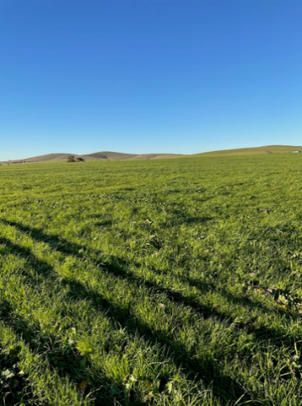
Figure 7. Single Species pasture, pre-graze

Figure 8. Mixed species pasture, pre-graze
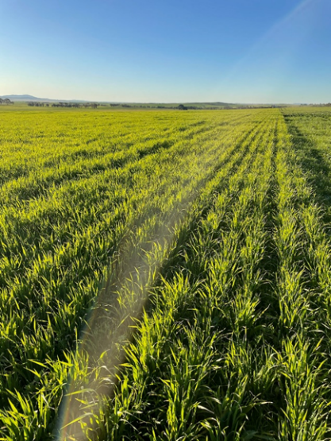
Figure 9. Sub zero (Brassica napus)

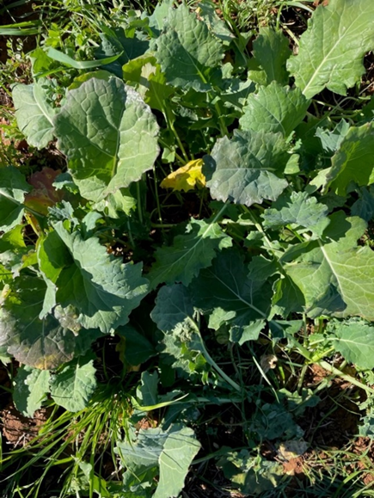
Satellite imagery - 2023
It was hypothesized that the mixed species pasture would have better FOO across the year and improved groundcover, however, the composition of the single species pasture resembled a mixed species pasture, as seen in Figure 7 & 8. As a result, field biomass measurements and satellite imagery estimates were similar for both treatments, as shown in Figures 10, 11 & 12.

Figure 10. Satellite imagery – mixed and single species pastures – September 2023.
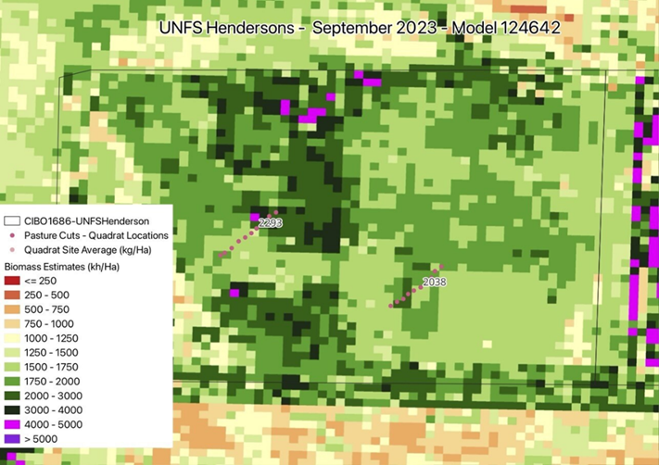
Figure 11. Satellite imagery – mixed and single species pastures – October 2023.
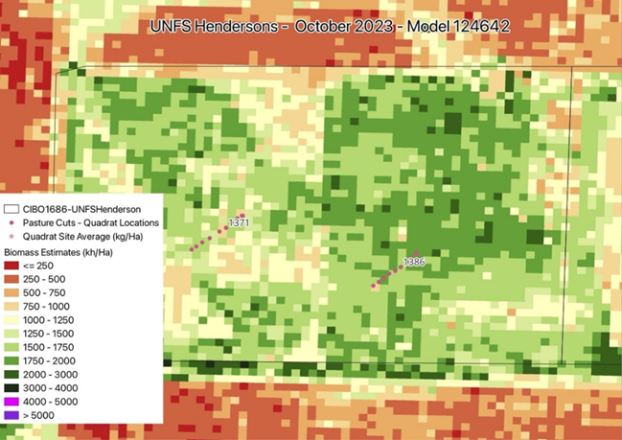

Figure 12. Biomass (t/ha) for two pasture treatments – forage brassica & forage brassica/vetch/barley.

Figure 13. A graphed comparison of field biomass cuts and satellite imagery estimates of TSDM (kg/ha) for September (post-grazing) and October (1 month recovery) 2023.

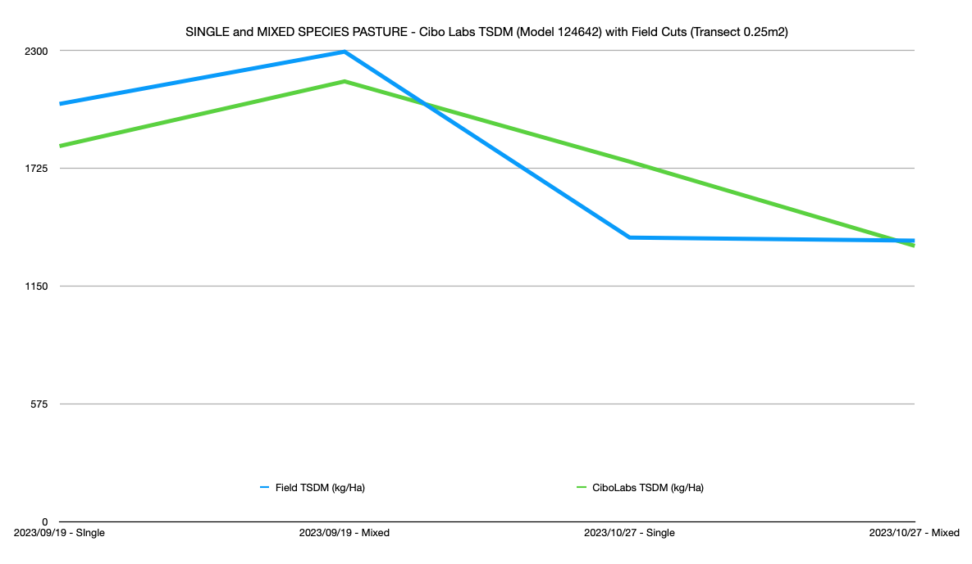
Biomass pasture cuts were sampled to ground truth satellite imagery estimates. Figure 13 presents results for September (post-grazing) and October (one month recovery post-grazing). The graphed data indicate confidence in the estimated Total Standing Dry Matter (TSDM, kg DM/ha). “Dry matter” refers to the weight of plant material excluding water, providing a consistent measure to compare feeds and pasture types across grazing systems or when developing livestock rations.
Pre-grazing measurements in July, however, showed poor correlation between biomass cuts and satellite imagery data. Accurate modelling of TSDM relies on sufficient field data, and there was insufficient data for early growth stages or lush green pastures, limiting the accuracy of estimates at these stages. Higher DM values corresponded with greater accuracy in modelled estimates. (Cibo Labs, 2023)
Similarly to 2022 results, no meaningful correlation could be identified from the biomass results for the two pasture treatments (forage brassica and forage brassica/vetch/barley) due to substantial establishment of volunteer species in the forage brassica treatment.
Sheep Weight Gain - 2023
It was predicted that the mixed species pasture would result in improved live weight growth in sheep. However, weight gain in 2023 was slightly higher for sheep grazing the single species pasture as shown in Table 2. This higher weight gain is attributed to a good balance of protein and energy giving better nutritional value shown in pasture feed test results for the single species pasture. The higher nutritional value of the single species pasture is explained by the higher sowing rates of subzero (5kg compared with 2kg/ha in mixed species) and therefore increased weight gain in sheep.

Feed test results - 2023
Forage brassicas are highly digestible with high metabolisable energy and low fibre content compared to other forage sources. They also provide adequate levels of crude protein for growing livestock. Brassicas also maintain their quality for longer than many other forage options, because they maintain a higher proportion of leaf and are often slower to initiate reproductive development. Hence, while brassicas may not produce as much biomass, their higher quality means they often provide equal or more metabolisable energy for livestock. (Ayres, et al, 2002)

Pre-graze feed test analysis - 2023
Single species (Sub zero @ 5kg/ha): The protein was very high on the single species pasture providing more than adequate protein for growing stock. As the single species was a brassica this is consistent with expectations for a brassica in growth phase. The digestibility is very high which is providing high quantities of metabolisable energy (12.5 MJ/kg DM). The fibre level of the pasture is optimum for rumen fiction and pasture intake at 31.7% of Dry matter. The Mixed Species pasture (Barley @ 65kg/ha, Vetch @ 40kg/ha, Sub zero @ 2kg/ha) has slightly higher dry matter pre-grazing (20.2% DM vs 16.7% DM in the brassica). The protein level was slightly lower at 16%, this will still provide adequate protein and provides a better protein versus energy ratio rather than the excess protein in the single species. The fibre level of the mixed species pasture was slightly above optimum and quite a bit more fibrous than the single species sub zero. The digestibility of the mixed species pasture was slightly lower (potentially due to the cereal species inclusion in the mix) meaning the metabolisable energy level provided was also lower at 11.9MJ/kg DM. The protein and energy balance of the mixed species pasture is closer to optimum, however the fibre levels of the mixed species pasture was higher than required for rumen function and optimum pasture intakes
(Feed test analysis provided by Deb Scammell, Talking Livestock)

Figure 14. Estimate of Feed on Offer (FOO) in total kg/paddock in AgriWebb App
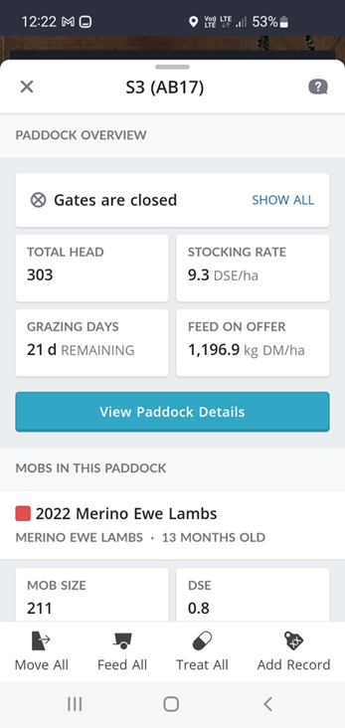
Grazing Decisions
In 2023, satellite imagery provided by CiboLabs was integrated into the producer’s farm management application – AgriWebb app. The imagery was used to estimate Feed on Offer (FOO) in total kilograms per paddock and to generate estimates of remaining grazing days as shown in Figure 14. These FOO estimates were utilised by the producer as a decision-support tool throughout the season. The grazing day estimates aligned closely with the producer’s anecdotal visual assessments of pasture availability during spring.
The use of satellite imagery to assess and monitor pasture growth in the Upper North has the potential to improve farmers’ capacity to undertake feed budgeting in the future. However, in this case, the producer did not consider that the cost of investment in the technology outweighed the perceived benefits under the conditions experienced during the project period

4.2 Economic analysis
No economic evaluation of this PDS was conducted – as explained in 2.2 Objectives.

4.3 Extension and communication
UNFS conducted annual workshops and other activities to showcase demonstration site results, increase the confidence of core and observer producers and encourage adoption of key practices by attending producers.
The PDS group consisted of 14 core producers and approximately 15 observer producers and some more attendees at extension activities outside of this PDS group like the UNFS Annual Expo’s. UNFS has delivered 6 extension activities and 10 communications over the four-year project.
Table 6. UNFS PDS Extension Activities
2022
Activity | Date | Technical Presenters | Topics | Attendance
Session 1:  PASTURE SITE STICKY BEAK  AND SATELLITE MAPPING  CRASH COURSE  Location: Melrose | Aug | Jess Koch, Breezy Hill Ag  Host producer case study: Kendrick McCallum  (PDS host) | - Crash course in satellite imagery  - Talk from Jess and facilitated discussion on the many uses for satellite imagery on farm including tools for assessment of food on offer | 12
Session 2  Annual UNFS Expo  Location: Booleroo Centre | Aug | FarmMap4D staff | - Booleroo Centre  - Pasture satellite imagery – FarmMap4D | 90
Session 3  Eastern Sticky Beak Day to PDS site | Sep | Morgan McCallum, PDS project facilitator  Host producer case study: Alison Henderson  (PDS host) | - PDS demonstration site visit (Caltowie site) – single vs mixed species pastures  - Facilitated discussion on pasture types  - Food on offer assessment methods and tools using satellite imagery  - Feed testing pastures – the value of knowing the nutritional value | 10
Session 4  Northern Sticky Beak Day to PDS site | Sep | Morgan McCallum, PDS project facilitator  Host producer case study: Richard McCallum  (PDS host) | - MLA PDS Site - Pekina site  - Medic Variteies Trial  - UNFS Canola trial - Morchard | 10
2023
Session 5  UNFS Annual Expo  Location: Booleroo Centre | Aug | Phil Tickle, Cibo Labs  Rachel Trengove – PDS facilitator | Update on Improved Pasture Management Systems PDS project – results so far _ Rachel  Using satelite imagery for grazing – estimating feed on offer and grazing days remaining in paddocks | 90
Session 6  LOTSA LAMBS workshop  Location: Caltowie | Sep | Michelle Cousins, Merino Services  Andrew Michael, Leachim Stud  Host producer case study: Alison Henderson (PDS Host | - As part of the LOTSA Lambs workshop, PDS site was visited – single and mixed species pasture  - Case study presentation included a project update by Alison Henderson & Rachel Trengove | 15
2025
Session 7  Workshop  Location: Caltowie | Sep | Cam Nicolson, Nicon Rural Services  Rachel Trengove – PDS facilitator  Alison Henderson, PDS Host – case study  Andrew Cootes – case study | Cam:  - Pasture growth basics  - Feed budgeting essentials  Rachel:  - PDS results & wrap up – single vs mixed species pastures at Caltowie  Alison:  - Case study – single vs mixed species  Andrew:  - Case study – cost:benefit of intensive rotational grazing in non-arable land in the upper north | 25
 |  |  |  | 252
Table 7. UNFS PDS Communications
Date | Communication type | Communication channel
2022
January | Email sent to UNFS members introducing the PDS project | Email (250 members)
February | Expressions of interest emails sent out to UNFS distribution list | Email (250 members)
February | Project summary – UNFS website  Producer Demonstration Site (PDS) 1 Improved Pasture Management Systems – Upper North Farming Systems | UNFS website
February | Project summary – MLA website Improved Pasture Management Systems | Meat & Livestock Australia | MLA Website
May | Article introducing the PDS hosts and locations and the PDS objectives and key practices being demonstrated. | Newsletter
September | Event summary – Session 1: Satellite imagery crash course | Newsletter
September | Event summary – Session 3&4: PDS site visits and updates | Newsletter
2023
May | PDS annual report – UNFS Compendium publication distributed to 250 members and posted on UNFS website  Publications – Upper North Farming Systems | UNFS Compendium
June | General PDS Project Update – sites and seasonal conditions | Newsletter
October | Factsheet “Using satellite imagery to support grazing decisions at a pasture demonstration site” – printed and distributed online and to members (250) Co-funded by SA Drought Hub SatelliteImageryFactSheet.indd | Print & online
2024
May | PDS annual report – UNFS Compendium publication distributed to 250 members and posted on UNFS website  Publications – Upper North Farming Systems | UNFS Compendium
2025
June | General PDS Project Update – sites and seasonal conditions | Newsletter
September | Event summary – Session 7: PDS site visit & workshop | Newsletter

- UNFS member number 250
- Quarterly newsletter is emailed to 250 members and posted on UNFS website
- UNFS social media posts include promotion of upcoming events and brief post event reports including photos – approximately 10,0000 UNFS Twitter and Facebook followers
- Newsletters and Compendium reports can be found on UNFS website; Upper North Farming Systems – Facilitating capacity building and empowerment of the Agricultural Community across the Upper North region
- Hard copy MLA publications were supplied to producers at workshops in topics related to the Improved Pasture Management Systems PDS with good numbers of publications taken home from events
- Enthusiastic facilitated discussion at workshops indicated engagement and effective peer to peer learning
- Guest speakers shared data from research outside of our UNFS demonstration sites and UNFS region to enhance exposure to latest research to intensify learning for farmers.

4.4 Monitoring and evaluation

Pre-project surveys
The pre-project survey results show that both Core and Observer producers entered the project with a moderate and varied level of confidence in pasture assessment and livestock management, and generally lower confidence in remote sensing and satellite mapping technologies. Most participants rated their pasture assessment skills as “somewhat good” to “neither good nor poor,” while knowledge of remote sensing was more commonly rated as “somewhat poor” or neutral, indicating clear scope for learning in this area. Confidence in determining food on offer was typically mid-range (around 4–7 out of 10), reflecting general awareness but inconsistent confidence across producers.
Across both Core and Observer groups, current management practices were mixed. Many producers already undertook core activities such as having a pasture phase in rotation, condition scoring sheep, or making informal assessments of food on offer, though the frequency and consistency varied widely. Practices such as regular sheep weighing, conducting feed tests, satellite mapping pastures, and sowing mixed species pastures were less commonly adopted, particularly among Observer producers. Core producers were slightly more advanced overall, with a higher proportion already using or intermittently applying these practices prior to the project.
When determining lamb readiness for weaning and grazing, producers relied on a range of indicators, including age of the animal, liveweight, physical soundness, and overall condition, with no single method dominating across all respondents. This diversity highlights different decision-making approaches and reinforces the relevance of the project in providing clearer, more objective tools to support these decisions.
The main barriers to adoption identified across both groups were limited time, limited skills or knowledge, and in some cases limited funds or infrastructure (such as fencing or technology). Notably, very few producers indicated that the practices were irrelevant to their business, suggesting strong underlying interest in improvement. Most respondents reported that they were already considering changes or would be likely to adopt new practices with appropriate support and information, establishing a solid baseline for engagement and behaviour change as the project progressed.
Overall, the pre-project surveys indicate that participants commenced the project with sound practical experience but inconsistent application of objective measurement and technology-enabled practices. The results demonstrate a clear opportunity for the PDS project to build skills, improve confidence, and support greater uptake of pasture assessment, feed management, and decision-support tools among both Core and Observer producers.

Post -project surveys
Eight completed post-project surveys were received, providing qualitative and indicative insights into producer experiences and perceived outcomes from the project. While the sample size limits the ability to undertake statistically robust analysis, the responses offer useful feedback on project delivery, relevance and future improvement.
Seasonal conditions had a significant influence on project implementation and outcomes. Two successive unfavourable seasons, including the 2024 drought, constrained pasture establishment and demonstration activities beyond the control of the project manager. In addition, several participating producers substantially reduced livestock numbers or exited sheep production entirely during the project period. These factors limit the extent to which definitive conclusions can be drawn from post-project survey results.
Notwithstanding these constraints, survey responses identified several consistent themes that will inform future research and extension activities. Three producer suggestions raised through the post-project surveys that will be considered by UNFS in future work include:
- Investigating perennial pasture options applicable to local areas, climate and farming systems
- Exploring pasture mixes best suited to regional conditions and individual paddocks
- Expanding demonstrations further north or east into drier production environments
A full summary of the post project survey results is available in appendix 7.4.

5. Conclusion

The Improved Pasture Management Systems PDS delivered by Upper North Farming Systems of South Australia has provided insights into mixed-species pasture performance under variable Upper North conditions, despite significant seasonal and site-based challenges. Demonstration sites in 2022 and 2023 confirmed that mixed-species pastures can establish successfully, support livestock production, and maintain groundcover, highlighting their potential as a flexible tool for producers seeking to diversify feed sources and improve system resilience. Sheep performance and biomass outcomes demonstrated that pasture quality and structure, rather than simply species diversity, play a key role in achieving optimal animal growth.

The project showcased satellite-based pasture monitoring technology, linking CiboLabs imagery to on-ground measurements, and demonstrated its utility in estimating Feed on Offer (FOO) and supporting grazing decisions. Extension and communication activities - including field days, workshops, publications, and peer-to-peer learning - effectively engaged producers, strengthened knowledge of pasture management, and built confidence in feed budgeting practices.

While climatic challenges and management disruptions limited the collection of multi-year data, precluding a full economic analysis and adoption evaluation, the project has nonetheless enhanced producer awareness, understanding, and practical skills. The learnings from this PDS will inform future pasture demonstrations, support ongoing innovation, and guide adaptive management strategies to improve sustainability and productivity across the Upper North agricultural region of SA.

5.1 Key Findings
- Satellite imagery is a useful tool for estimating pasture biomass but cannot reliably predict pasture composition or quality and is generally more accurate when assessing dry feed than lush, green feed. Future satellite or drone technologies may help address this limitation.
- Satellite imagery should not be used in isolation for grazing decisions; pairing imagery with ground-truthing, pasture composition assessments, and feed tests (e.g., dry matter percentage) enhances decision-making.
- Understanding soil variability and seasonal growing conditions is critical when interpreting satellite imagery for grazing management.
- Effective pasture management requires addressing both agronomic factors (e.g., species selection, sowing rates, soil fertility) and grazing management.
- More trials across a range of seasons are needed to improve the accuracy and reliability of satellite- and ground-based predictive methods.
- The PDS demonstration was conducted during challenging seasons, highlighting the importance of flexible, adaptable management strategies.
- Adoption of satellite-based pasture monitoring is limited by the availability of specialised providers for grazing systems.
- There is a skills gap in optimising low-rainfall pasture systems, as most agronomists and industry experts focus on medium- and high-rainfall regions.

5.2 Benefits to industry
Practical application and implications for the red meat industry

Increased pasture diversification: Incorporating multiple pasture species within mixed farming rotations can improve system resilience, spread production risk and better manage seasonal variability in low–medium rainfall environments. Diversified pastures offer greater flexibility for grazing management while supporting long-term enterprise sustainability.

Improved livestock husbandry and feed matching: The use of biomass estimation tools, ground-truthing and feed testing enables producers to better match Feed on Offer (FOO) with livestock nutritional requirements. Maintaining appropriate condition scores and avoiding over- or under-grazing improves animal health, reproductive performance and overall productivity. This is particularly critical during drought or feed-limited periods, where inefficient feeding decisions can significantly impact business performance.

Improved soil cover and reduced erosion risk: Enhanced understanding of grazing timing and intensity supports maintenance of groundcover over summer. Protecting soil from wind and water erosion preserves productive topsoil, safeguards long-term land capability and supports the sustainability of red meat production systems.

Improved decision-making and producer confidence: Access to objective monitoring tools reduces reliance on purely visual or emotive decision-making, particularly during drought. Structured feed budgeting and monitoring frameworks support clearer, evidence-based grazing decisions, contributing to improved business resilience and producer wellbeing.

Improved profitability potential: Remote sensing technologies provide time-efficient, non-destructive pasture monitoring across large or inaccessible areas, reducing labour demands while supporting more precise grazing management. These tools have potential to improve resource allocation and overall enterprise profitability.

Key challenges and considerations for future investment

- Seasonal variability and drought significantly impacted data continuity, reinforcing the need for longer-term investment across multiple seasons to strengthen predictive confidence.

- Current satellite technologies have limitations in predicting pasture composition and quality, indicating an opportunity for further development of remote sensing tools tailored to grazing systems.

- Limited availability of specialist pasture-monitoring providers and expertise in low-rainfall grazing systems may constrain adoption, suggesting value in continued industry investment in technical capability and extension.

6.References

- Sanderson, M. A., et al. (2013). Diversification and ecosystem services for conservation agriculture: Outcomes from pasture and forage systems. Renewable Agriculture and Food Systems, 28(2), 129–144.
- Bureau of Metreology, (BOM) 2024
- Meat and Livestock Australia (MLA) website, 2026.
- Forage brassicas – quality crops for livestock production, Linda Ayres,
Bruce Clements, 2002.

7. Appendix

7.1 Monitoring and evaluation plan
MER Plan: Producer Demonstration Sites

Project Number & Name: Improved Pasture Management Systems L.PDS.2201

Date: 9/02/22

Evaluation level | Generic Performance Measures (example) | Project Performance Measures  (Please fill in and delete example) | Evaluation Methods  (Please fill in and delete example)
Inputs – What did we do?  Describe the planned and expected inputs involved in your project, including funds, resources, development & projects structures | - Number of core producers involved in demonstration sites & their demographics  - Number of producers observing demonstration sites & their demographics  - Number of head of livestock involved  - Area (ha) involved  - Project steering committee decisions and notes  - Investments ($’s) from MLA and other parties (cash and in-kind contributions) and what was purchased – professional time, project inputs | - Plan to have three demonstration sites a year. 3 producers for 2022 will be involved across the Upper North Region  - 150 producers will be observing the demonstration sites through the UNFS membership base  - Minimum 10 ha paddocks will be used at each demonstration sites.  - In kind total investments:$69200 | - Notification that sites will be needed for the 2022 season will be emailed out to UNFS operations steering committee and UNFS members.  - Sites will be evaluated by yard set up and suitable paddock arrangements.  - Steering committee minutes  - Project budgets
Outputs - What did we do?  Describe the outputs planned/expected from your project, including engagement activities & products from demonstration sites | - Outputs from demonstration sites (new knowledge & data) (e.g., reproduction rate, weaning rate, mortality rate, gender, management methods, cost of vaccine, extra labour, and cost of production)  - Field days held, demographics collected, and M&E conducted  - Media events/outputs | - Outputs will include:  - 3 demonstration site visits per year (1 at each site)  - Results from demonstration sites  - Newsletter summaries  - Social media post  - UNFS Membership emails  - Case studies at the end of each year to be published in the UNFS annual compendium  - 3 total workshops in year 2023, 2024 | - Site visits will be conducted by the project manager with support of UNFS staff and promoted through social media and membership emails.  - Database of data from demo sites  - Through workshops, training will be supplied in satellite monitoring, pasture sampling and assessment suited to ground truthing satellite images and feed budgeting, food on offer and pasture planning within rotations.  - Newsletter summaries will include any photos and updates on the trial  - Case studies will be written within UNFS and published annually in the UNFS compendium  - Workshops will be coordinated by the project manager and will have the ability to have guest speakers.
Changes in knowledge, attitudes, and skills – How well did we do it?  Describe the changes in KASA that you are planning to achieve. | - Change in knowledge/attitudes/skills of core and observer participants before and after project/activity  - Experience of producers involved in the PDS – extent to which they found the project/ activity useful or of value. | - A better understanding of food on offer, including feed budgeting and the use of remote sensing pasture assessment tools that will prove the overall livestock productivity, enterprise productivity and farm sustainability within the core group of 60% of producers involved.  - New knowledge on pasture options that improve the mixed farming enterprise. | - Pre and post producer surveys
Practice changes – Has it changed what people do?  Describe the practice changes that you are expecting to achieve by the end of your project | - Producer (core & observer) practice (relevant to the topic/project) before and after project  - Influence the project had on practice change achieved | - Core/engaged producers (60% of producers) will have adopted improved pasture mixes that have resulted in either an improved biomass production by 10% or groundcover over summer by 5% depending on the pasture mix and site objectives.  - Observers (measured from workshop and field day participants) will have adopted improved pasture mixes that have resulted in either an improved biomass production by 10% or groundcover over summer by 5% depending on the pasture mix and site objectives. | - Pre and post producer surveys
Benefits – Is anyone better off?  Describe the benefits that you are expecting to achieve as a result of the project | - Benefits / impacts from practice change (e.g. $ value of decreased mortality rate compared to baseline)  - Costs to achieve outcomes (e.g. increased inputs, labour)  - Benefit Cost and Sensitivity analyses at the business level | - Benefit cost analysis of improved pasture management systems  - Better pasture management throughout the Upper North Region  - Pastures being better implemented into a rotation  - Increased lamb growth rates by 100gms per day, condition scores and body weights  - Increased biomass and ground cover by 30%.  - Increased farm productivity and sustainability | - Results of benefit cost analysis  - Throughout all of the projects planned outputs, a successful outcome will be that all benefits listed will be achieved through trial findings and promoted through the UNFS membership base and socials
General observations / outcomes – Is the industry better off? | - Potential impacts (practice change & productivity) at the end of the project and well after the project has concluded (e.g., 2 years later) for the broader target audience  - What are the unintended/unexpected benefits or consequences?  - Project learnings, barriers / enablers to adoption | - There will be expected changes in producers’ knowledge and adoption of remote pasture monitoring by the core group  - Changes in producers’ confidence to accurately assess food on offer and the use of feed budgeting | - Shifting practices on farm can benefit core producers within the upper north region, these changes can be implemented in areas with similar rainfall and soil types across mixed farm enterprises.  - Interview of steering committee members to obtain key project learnings and any unexpected benefits or consequences

7.2 Pre Project survey templates
MLA Producer Demonstration Sites
Pre-project Survey - Core Participants
PDS Name (to fill out by PDS coordinator): Improved Pasture Systems
PDS Project Code (to fill out by PDS coordinator): L.PDS.2201
The following questions are used to determine your level of understanding of Improved Pasture Systems. The knowledge and skills audit is used at the start and completion of the program to allow individuals to track their skill development and adoption of new practices. It will also be used:
- To improve the content of future project meetings; and
- As part of the evaluation process for the project
The information will be completely confidential, and individuals will not be identified in the analysis of data.
Participant Name: _________________________________________________________________
Date: / /

MLA may contact me to further assess the impact of their programs? □ Yes □ No
MLA may send me newsletters and inform me of future events? □ Yes □ No
I have read, understood and accept the terms of MLA’s “PDS Participant
Consent & Release” (see appendix 1) □ Yes □ No

Participant Signature: _______________________________________________________________

Section A – Demographic Information
- Your contact details
Company/Business Name:
Property Address:
(Incl. Property Name)
Name:
Phone Number: |  | Mobile:
Email Address:
Postal Address:

Are you a:
◻ Sheepmeat producer  (>50% farm income) | ◻ Beef producer  (>50% farm income) | ◻ Beef and/or sheep + cropping producer
◻ Other (please specify) _____________________________

- Please tell us about your enterprise
Area Managed:  (in hectares) |  | Number of beef breeders: |  | Number of cattle turned off per year: |  | Total Number of cattle:
Number of Ewes: |  | Number of lambs turned off each year |  | Total Number of Sheep |  | Number of goats turned off per year:

Section B – Knowledge and Skills (If you do not know, please select the 'Unsure' option)
B1. How would you rate your knowledge and skill in pasture assessment?
- Very good □
- Somewhat good □
- Neither good or poor □
- Somewhat poor □
- No knowledge □
- Other (please state) □
B2. What is the most important aspect in determining when to graze lambs?
- Lamb condition score □
- Lamb weight □
- Animal age □
- Ground cover □
- Food on offer □
- Other (Please describe) □
- Unsure □
B3. How would you rate your knowledge in remote sensing and satellite mapping?
- Very good □
- Somewhat good □
- Neither good or poor □
- Somewhat poor □
- No knowledge □
Other (please state)
B4. How would you determine when a lamb is ready to be weaned and grazed? (Tick the answer that applies to you)
- Liveweight □
- Age of animal □
- Condition score of 3-3.5 □
- Physically sound □
- Unsure □

Section C – Confidence and Practice.
- In relation to determining food on offer please rate your attitude, and confidence, where 1 being very poor and 10 being very good, by marking your choice below:
 | 1  Very Poor | 2 | 3 | 4 | 5 | 6 | 7 | 8 | 9 | 10  Very Good
Attitude
(Interest/Disinterest)
Confidence
- Do you currently use the following practices?
 | Normal practice | Sometimes | Rarely | Never | Not Applicable
Weigh Sheep regularly
Have a pasture phase in rotation
Make assessments of food on offer
Do pasture tests
Condition score sheep
Satellite map paddocks
Do mixed species cropping
Other

C2.1 What are the reasons you have not implemented the above practices on your property?
(Tick any of the options that apply to you)
◻ Not a significant issue on my property | ◻ Lack of confidence | ◻ Lack of skills
◻ Limited funds | ◻ Limited time | ◻ Other (please specify)

C3. Are you already considering making any specific changes within your business relevant to the project?
 | Yes  Or  No | Likelihood of making this change:
 | Yes  Or  No | Very unlikely | Unlikely | Possible need more information | Likely, with support/additional information | Likely | Very likely
Weigh Sheep regularly
Have a pasture phase in rotation
Make assessments of food on offer
Do pasture tests
Condition score sheep
Satellite map paddocks
Do mixed species cropping

- For the key metrics you are seeking to demonstrate in this PDS, please advise what is your current performance

Metric | Current performance
Ability to split paddock into minimum 10ha sections
Weigh sheep regularly (2-3 times a year)
Condition score regularly (2-3 times a year)

MLA Producer Demonstration Sites
Pre-project Survey - Observer Participants

PDS Name: Improved Pasture Systems
PDS Project Code: L.PDS.2201
The following questions are used to determine your level of understanding of improved pasture systems. The knowledge and skills audit is used at the start and completion of the program to allow individuals to track their skill development and adoption of new practices. It will also be used:
- To improve the content of future project meetings; and
- As part of the evaluation process for the project
The information will be completely confidential, and individuals will not be identified in the analysis of data.

Participant Name: ________________________________________________________________
Date: / /

MLA may contact me to further assess the impact of their programs? □ Yes □ No
MLA may send me newsletters and inform me of future events? □ Yes □ No
I have read, understood and accept the terms of MLA’s “PDS Participant
Consent & Release” (see appendix 1) □ Yes □ No

Participant Signature: _______________________________________________________________

Section A – Demographic Information
- Your contact details
Company/Business Name:
Property Address:
(Incl. Property Name)
Name:
Phone Number: |  | Mobile:
Email Address:
Postal Address:

Are you a:
◻ Sheepmeat producer  (>50% farm income) | ◻ Beef producer  (>50% farm income) | ◻ Beef and/or sheep + cropping producer
◻ Other (please specify) _____________________________

- Please tell us about your enterprise
Area Managed:  (in hectares) |  | Number of beef breeders: |  | Number of cattle turned off per year: |  | Total Number of cattle:
Number of Ewes: |  | Number of lambs turned off each year |  | Total Number of Sheep |  | Number of goats turned off per year:

Section B – Knowledge and Skills (If you do not know, please select the 'Unsure' option)
B1. What is the most important aspect in determining when to graze lambs?
- Lamb condition score □
- Lamb weight □
- Animal age □
- Ground cover □
- Food on offer □
- Other (Please describe) □
- Unsure □
B2. What do you usually graze sheep on: (Tick one of the options below)
- Vetch □
- Oats □
- Annual Medics □
- Crop mix (eg. vetch/barley, oats/canola, medic/wheat) □
- Unsure □
B3. How would you determine when a lamb is ready to be weaned and grazed? (Tick the answer that applies to you)
- Liveweight □
- Age of animal □
- Condition score of 3-3.5 □
- Physically sound □
- Unsure □

Section C – Confidence and Practice.
- In relation to determining food on offer please rate your attitude, and confidence, where 1 being very poor and 10 being very good, by marking your choice below:

 | 1  Very Poor | 2 | 3 | 4 | 5 | 6 | 7 | 8 | 9 | 10  Very Good
Attitude
(Interest/
Disinterest)
Confidence

- Do you currently use the following practices?
 | Normal practice | Sometimes | Rarely | Never | Not Applicable
Weigh Sheep regularly
Have a pasture phase in rotation

C2.1 What are the reasons you have not implemented the above practices on your property?
(Tick any of the options that apply to you)
◻ Not a significant issue on my property | ◻ Lack of confidence | ◻ Lack of skills
◻ Limited funds | ◻ Limited time | ◻ Other (please specify)

C3. Are you already considering making any specific changes within your business relevant to the project?
 | Yes  or  No | Likelihood of making this change:
 | Yes  or  No | Very unlikely | Unlikely | Possible need more information | Likely  with support/  additional information | Likely | Very likely
Implementing a pasture option into your rotation
Grazing lambs on annual medic pastures

- For the key metrics you are seeking to demonstrate in this PDS, please advise what is your current performance

Metric | Current performance
Ability to split paddock into minimum 10ha sections
Weigh sheep regularly (2-3 times a year)
Condition score regularly (2-3 times a year)

C5. If Not Applicable, please provide reason why
_____________________________________________________________________________________________________________________________________________________________________________________________________

7.3 Post project survey template
Post-Project Survey – {Core/Observer} Participants

PDS Project Code: | L.PDS.2201 | PDS Project Name : | Improved Pasture Management Systems

The following questions are used to determine your level of understanding of improved pasture management systems following your participation in the above producer demonstration site project. The knowledge and skills survey used at the start and completion of the program will allow individuals to track their skill development and adoption of new practices. The information will be used used as part of the evaluation process for the project and MLA’s PDS program. The information will be completely confidential, and individuals will not be identified in the analysis of data.
Participant Name:
Company/Business Name:

Section A - Your thoughts on the PDS
Please rate each of the questions below out of 10 (where 1 is negative and 10 is positive)

- Overall, how satisfied are you with this PDS? ______/10

- How valuable was this PDS in assisting you manage your livestock enterprise? ______/10
Please tick your response and provide short answer responses for the below questions
- Would you recommend MLA’s PDS program to others? ☐ Yes ☐ No ☐ Not Sure
____________________
- Please provide any feedback to help us improve the PDS program:

Section B – Knowledge and Skills (If you do not know, please select the 'Unsure' option)
- Overall, how well has this PDS project increased your knowledge and skills of pasture assessment?
Please rate out of 10 by marking your choice below, 1 = No Increase, 10 = very large increase
1 | 2 | 3 | 4 | 5 | 6 | 7 | 8 | 9 | 10
☐ | ☐ | ☐ | ☐ | ☐ | ☐ | ☐ | ☐ | ☐ | ☐

- Overall, how well has this PDS project increased your knowledge & skills in remote sensing?
Please rate out of 10 by marking your choice below, 1 = No Increase, 10 = very large increase
1 | 2 | 3 | 4 | 5 | 6 | 7 | 8 | 9 | 10
☐ | ☐ | ☐ | ☐ | ☐ | ☐ | ☐ | ☐ | ☐ | ☐
- What is the most important aspect in determining when a lamb is ready to be weaned and grazed? (Tick one of the options below)
- Liveweight o
- Age of animal o
- Condition score of 3-3.5 o
- Physically sound o
- All of the above o

Section C – Confidence and Practices
- How confident are you in determining food on offer?
Please rate out of 10 by marking your choice below, 1 = Not at all confident, 5 = somewhat confidence, 10 = very confident
1 | 2 | 3 | 4 | 5 | 6 | 7 | 8 | 9 | 10
☐ | ☐ | ☐ | ☐ | ☐ | ☐ | ☐ | ☐ | ☐ | ☐

- As result of participating in this PDS have you adopted any of the following practices:
Practices | Practice Implemented? | Indicate on what % of your enterprise this practice has been adopted  (if not adopted leave blank) | Frequency of use?  (if not adopted leave blank)
Weigh Sheep regularly | ☐ Yes, practice implemented  ☐ I intend to implement  ☐ No, I have no intentions to  ☐ Adopted prior to PDS  ☐ Not applicable | ☐ Less than 25%  ☐ Between 25% - 50%  ☐ 50%  ☐ Between 50% - 75%  ☐ Greater than 75%  ☐ 100% | ☐ Normal Practice  ☐ Sometime  ☐ Rarely
Weigh Sheep regularly | What are the reasons you have not implemented this practice on your property?
  ☐ Not a significant issue on my property | ☐ Lack of confidence | ☐ Lack of skills
  ☐ Limited funds | ☐ Limited time | ☐ Other (please specify)
Have a pasture phase in rotation | ☐ Yes, practice implemented  ☐ I intend to implement  ☐ No, I have no intentions to  ☐ Adopted prior to PDS  ☐ Not applicable | ☐ Less than 25%  ☐ Between 25% - 50%  ☐ 50%  ☐ Between 50% - 75%  ☐ Greater than 75%  ☐ 100% | ☐ Normal Practice  ☐ Sometime  ☐ Rarely
Have a pasture phase in rotation | What are the reasons you have not implemented this practice on your property?
  ¨ Not a significant issue on my property | ¨ Lack of confidence | ¨ Lack of skills
  ¨ Limited funds | ¨ Limited time | ¨ Other (please specify)
Make assessments of food on offer | ☐ Yes, practice implemented  ☐ I intend to implement  ☐ No, I have no intentions to  ☐ Adopted prior to PDS  ☐ Not applicable | ☐ Less than 25%  ☐ Between 25% - 50%  ☐ 50%  ☐ Between 50% - 75%  ☐ Greater than 75%  ☐ 100% | ☐ Normal Practice  ☐ Sometime  ☐ Rarely
Make assessments of food on offer | What are the reasons you have not implemented this practice on your property?
  ¨ Not a significant issue on my property | ¨ Lack of confidence | ¨ Lack of skills
  ¨ Limited funds | ¨ Limited time | ¨ Other (please specify)
Conduct feed tests on pastures | ☐ Yes, practice implemented  ☐ I intend to implement  ☐ No, I have no intentions to  ☐ Adopted prior to PDS  ☐ Not applicable | ☐ Less than 25%  ☐ Between 25% - 50%  ☐ 50%  ☐ Between 50% - 75%  ☐ Greater than 75%  ☐ 100% | ☐ Normal Practice  ☐ Sometime  ☐ Rarely
Conduct feed tests on pastures | What are the reasons you have not implemented this practice on your property?
  ¨ Not a significant issue on my property | ¨ Lack of confidence | ¨ Lack of skills
  ¨ Limited funds | ¨ Limited time | ¨ Other (please specify)
Condition score sheep | ☐ Yes, practice implemented  ☐ I intend to implement  ☐ No, I have no intentions to  ☐ Adopted prior to PDS  ☐ Not applicable | ☐ Less than 25%  ☐ Between 25% - 50%  ☐ 50%  ☐ Between 50% - 75%  ☐ Greater than 75%  ☐ 100% | ☐ Normal Practice  ☐ Sometime  ☐ Rarely
Condition score sheep | What are the reasons you have not implemented this practice on your property?
  ¨ Not a significant issue on my property | ¨ Lack of confidence | ¨ Lack of skills
  ¨ Limited funds | ¨ Limited time | ¨ Other (please specify)
Satellite map pasture paddocks | ☐ Yes, practice implemented  ☐ I intend to implement  ☐ No, I have no intentions to  ☐ Adopted prior to PDS  ☐ Not applicable | ☐ Less than 25%  ☐ Between 25% - 50%  ☐ 50%  ☐ Between 50% - 75%  ☐ Greater than 75%  ☐ 100% | ☐ Normal Practice  ☐ Sometime  ☐ Rarely
Satellite map pasture paddocks | What are the reasons you have not implemented this practice on your property?
  ¨ Not a significant issue on my property | ¨ Lack of confidence | ¨ Lack of skills
  ¨ Limited funds | ¨ Limited time | ¨ Other (please specify)
Sow mixed species pastures | ☐ Yes, practice implemented  ☐ I intend to implement  ☐ No, I have no intentions to  ☐ Adopted prior to PDS  ☐ Not applicable | ☐ Less than 25%  ☐ Between 25% - 50%  ☐ 50%  ☐ Between 50% - 75%  ☐ Greater than 75%  ☐ 100% | ☐ Normal Practice  ☐ Sometime  ☐ Rarely
Sow mixed species pastures | What are the reasons you have not implemented this practice on your property?
  ¨ Not a significant issue on my property | ¨ Lack of confidence | ¨ Lack of skills
  ¨ Limited funds | ¨ Limited time | ¨ Other (please specify)

  - Have you made/do you intend to make any other changes to your business as a result of participating in this PDS? If yes, please advise what changes
______________________________________________________________________________________________________________________________________________________________________________________________________

7.4 Summary of post project survey results
Project: L.PDS.2201 Improved Pasture Management Systems
Survey responses: n = 8
- Overall Satisfaction and Value
Survey results indicate strong overall satisfaction with the Producer Demonstration Site (PDS).
- Overall satisfaction:
  - Mean rating 7.9 / 10 (median 8; range 5–10)
- Perceived value to livestock enterprise management:
  - Mean rating 7.5 / 10 (median 8)
Most respondents indicated they would recommend MLA’s PDS program to others. Qualitative feedback highlighted the practical relevance of the project, clear objectives, and the value of shared learning and discussion with other producers.
- Knowledge and Skills Development
Participants reported moderate to strong improvements in knowledge and skills as a result of participating in the PDS.
- Pasture assessment knowledge and skills:
  - Mean rating 7.3 / 10
- Remote sensing knowledge and skills:
  - Mean rating 6.3 / 10
Responses suggest the project was effective in improving producers’ understanding of pasture condition, food-on-offer assessment, and the application of remote sensing tools to support livestock and grazing decisions.
- Practice Adoption and Intended Change
Survey responses demonstrate a combination of existing practice adoption, adoption during the project, and intention to adopt, reflecting the diverse starting positions of participating enterprises.
Practices most commonly reported as:
- Already adopted or implemented:
  - Weighing sheep
  - Including pasture phases in crop or grazing rotations
  - Making regular assessments of food on offer
  - Condition scoring sheep
- Intended for future adoption:
  - Conducting feed tests on pastures
  - Increased use of satellite pasture mapping
  - Sowing mixed species pastures where appropriate
Where practices were not adopted, participants most commonly cited:
- Time constraints
- Competing enterprise priorities
- Practices not suited to their property or production system
- Broader Business Changes
Several respondents reported broader changes to their business as a result of participation, including:
- Continued and increased use of condition scoring
- Ongoing pasture assessment to inform stocking rate and grazing decisions
- Investigation of pasture species and mixes better suited to local conditions, climate and farming systems
- Participant Feedback
Positive feedback emphasised:
- Clear, concise and practical information
- Useful reinforcement of pasture–livestock decision-making
- Benefits of producer interaction and discussion
Suggestions for improvement included:
- Locating demonstration sites closer together where possible
- Expanding demonstrations into additional regions and seasonal conditions
- Continued balance between emerging technologies and practical, on-farm application
- Summary
The post-project survey indicates the PDS successfully delivered relevant, practical outcomes for participating producers, resulting in increased knowledge, improved confidence in pasture and livestock management decisions, and both current and intended changes to on-farm practices. The feedback provides valuable insights to support the continued refinement and delivery of future Producer Demonstration Site projects.

7.5 Communication plan
Communications plan – Improved Pasture Management Systems L.PDS.2201

Prepared by: Morgan McCallum, morgan@unfs.com.au, 0459718181
Background
The Upper North Agricultural Zone of South Australia is a predominantly mixed farming system incorporating a rotation of pastures and cereal and/or legume/canola cropping. Over 85% of the farmers in the region operate under this model, however there are significant challenges balancing the needs of the cropping enterprise with a livestock production system.
Currently this pasture phase is often a monoculture of medic or vetch to provide a grass free break to the cropping rotation and build N in the soil for the following cereal. There are problems associated with grazing of a monoculture including animal health issues such as red gut, bloat, pulpy kidney and cow pea aphid toxicity. They are also slow to establish in the cold winter climate of the region and produce limited residues exposing the soil to erosion over the summer period. Producers are interested to assess whether a mixed sown pasture can provide equal or better food on offer (FOO) and superior animal performance, improve soil cover and do so without negative implications for the cropping program.
Many producers are becoming aware of the importance of feed budgeting and understanding their available FOO, however with limited labour units on most farms, producers struggle to fit this assessment into their work program. Producers have outlined the need for better understanding of FOO, pasture quality, feed budgeting and are interested to assess alternative tools available to make planning and managing pastures easier and therefore more likely to be done.
Challenge/opportunity
Farming rotations in the UNFS region typically include a pasture rotation, incorporating sheep grazing. Currently this pasture phase is often a monoculture of medic or vetch. There are problems associated with grazing of a monoculture including animal health issues such as red gut, bloat, pulpy kidney and cow pea aphid toxicity. Producers are interested to assess whether a mixed pasture can provide equal or better food on offer (FOO) and superior animal performance, without negative implications for the cropping program. Many producers are becoming aware of the importance of feed budgeting and understanding their available FOO. With limited labour units on most farms, producers struggle to fit this assessment into their work program and are interested to assess alternative tools available to make this job easier and therefore more likely to be done. Through field days and paddock walks and training sessions organised by Upper North Farming Systems, producers will be able to see the demonstration sites firsthand and build their knowledge on improved pasture systems.
Project objectives
The project objectives are as follows:
By January 2025, in the Upper North region of South Australia:
- Demonstrate three options for a mix of pasture/fodder species that can provide superior FOO measured by:
  - Improved liveweight growth of lambs
  - Improved CS of ewes
  - Improved biomass production
  - Improved ground cover
- Conduct an analysis of the cost: benefit of the trialled pasture mixes
- Adoption:
  - 60% of core/engaged producers will have adopted improved pasture mixes that have resulted in either an improved biomass production by 10% or groundcover over summer by 5% depending on the pasture mix and site objectives.
  - 10% of observers (measured from workshop and field day participants) will have adopted improved pasture mixes that have resulted in either an improved biomass production by 10% or groundcover over summer by 5% depending on the pasture mix and site objectives.
- Awareness, Knowledge and Skills:
  - 100% of core/engaged producers will have an improved understanding of pasture mixes, the role they play in improved biomass production and maintaining groundcover over summer and how to measure and manage them to improve livestock production outcomes.
  - 50% of observers (measured from workshop and field day participants) will have improved understanding of pasture mixes, the role they play in improved biomass production and maintaining groundcover over summer and how to measure and manage them to improve livestock production outcomes.
- Conduct ground truthing for Cibo Labs at 3 sites across the region on at least 6 different pasture types (3 sown mixed pastures (demonstrations), 3 single species or self-regenerating pastures (controls))
- Demonstrate the use of satellite pasture monitoring technology for feed budgeting and encourage adoption of the new technology by 6 producers
We propose a wide range on communication and extension activities throughout the course of the PDS sites, these include:
- Field days and paddock walks at the pasture demonstration sites - Minimum of 1 site visit per site per year (3 total per year).
- Training workshop with satellite monitoring service provider
- Training in pasture sampling and assessment suited to ground truthing the satellite images
- Training in Feed Budgeting, FOO, Pasture planning.
- Promotion to the wider group community through already established UNFS communication strategies including quarterly members' newsletter, UNFS Facebook and Twitter accounts, annual compendium, and annual members' forum
Therefore, the total Annual Communication Activities - 4 events per year. 3 annual reports/case studies, 4 biomass updates/remote updates, 4 media releases per year, 9-12 social media posts per
year extending demonstrations site messaging.
Target audience
Target audience for these communication outcomes are the sheep and pasture producers within the Upper North Region of South Australia. The Upper North Agricultural Zone of South Australia includes the area from Port Augusta – Crystal Brook – Burra – Peterborough and everywhere in-between. As our membership base and other local farmers vary in age, Upper North Farming Systems will deliver these communication strategies in several ways to cater for a vast range of audience preferences with online updates, in person updates and in the form of articles and newsletters.
Key messages
- To improve the pasture management systems implemented in the Upper North of South Australia through demonstrating:
  - 1. Better pasture options that improve the mixed farming enterprise
  - 2. That a better understanding of Food on Offer, including feed budgeting and the use of remote sensing pasture assessment tools will improve overall livestock productivity, enterprise profitability and farm sustainability.
- The project involves a partnership between Upper North Farming Systems and local producers to demonstrate research findings on commercial properties through Morgan McCallum from Upper North Farming Systems.
- The first year of this project was initiated by Upper North Farming Systems.
- Producer Demonstration Sites are funded by MLA to support producer through peer-to-peer groups to pursue new skills, knowledge, and management practices applicable to their own commercial livestock production systems.
- This Producer Demonstration Site is funded by Meat & Livestock Australia is included on all communication materials and in-kind contributions.
Budget
Activity | 2021/ 2022 | 2022/ 2023 | 2023/2024 | 2024/2025
Case Studies | - | $1000 | $1000 | $100
Site Visits / Workshops | - | $8000 | $7000 | $3000
Newsletter Summaries | $150 | $150 | $150 | $150
Article In Annual Compendium | - | $500 | $500 | $500
Videography | - | - | - | $4000
Social Media Posts | $0 | $0 | $0 | $0

Channel/timing matrix
Timing (2022) | Communications tactics (e.g. written producer case study, video) | Communications channel  (e.g. Feedback magazine, media release) | Messages
June | Newsletter Article | Quarterly newsletter, sent out to membership base | Notifying members where demonstration sites are and any updates on what has been established.
July-October | Site Visits – 3 in total, one to each site | Promoted through UNFS website, membership base through email and social media – both Facebook and Twitter. | Official flyer and invitation to site visit. Alerting members of any guest speakers that may come along.
December | Case studies 2022 | Distributed through membership base and social media platforms | Key messages and findings from the 2022 sites.
Timing (2023) | Communications tactics (e.g. written producer case study, video) | Communications channel  (e.g. Feedback magazine, media release) | Messages
Jan-March | Workshop 1 – Accessing and interpreting Remote Sensing Data for improved pasture management. | Promoted through UNFS website, membership base through email and social media – both Facebook and Twitter. | Official flyer and invitation to site visit. Alerting members of any guest speakers that may come along.
May | Results published in UNFS Research Compendium | Distributed through the UNFS membership base in the form of a hard copy and digital. Promoted through social and membership email base. | Mentioned at events, newsletter and through social media.
Jun-Oct | Site visits to demonstration sites (3 total) | Promoted through UNFS website, membership base through email and social media – both Facebook and Twitter. | Official flyer and invitation to site visit. Alerting members of any guest speakers that may come along.
Jun-Oct | Workshop 2 – Ground Truthing and Monitoring for Pasture Biomass, FOO and Pasture Quality | Promoted through UNFS website, membership base through email and social media – both Facebook and Twitter. | Official flyer and invitation to site visit. Alerting members of any guest speakers that may come along.
Dec | Case Studies 2023 Compiled | Distributed through membership base and social media platforms | Key messages and findings from the 2023 sites.
Timing (2024) | Communications tactics (e.g. written producer case study, video) | Communications channel  (e.g. Feedback magazine, media release) | Messages
Jan-March | Workshop 3 – Assessing FOO, feed budgeting and planning pastures to minimise feed gap and  maximise biomass production within a mixed farming enterprise. This will incorporate MLA products  and tools. | Promoted through UNFS website, membership base through email and social media – both Facebook and Twitter. | Official flyer and invitation to site visit. Alerting members of any guest speakers that may come along.
May | 2023 Results published in UNFS Research Compendium | Distributed through the UNFS membership base in the form of a hard copy and digital. Promoted through social and membership email base. | Mentioned at events, newsletter and through social media.
Jun-Oct | Site visits to demonstration sites (3 total) | Promoted through UNFS website, membership base through email and social media – both Facebook and Twitter. | Official flyer and invitation to site visit. Alerting members of any guest speakers that may come along.
Dec | Case Studies 2024 Compiled | Distributed through membership base and social media platforms | Key messages and findings from the 2023 sites.
Dec | 2024 Results compiled for publication in the UNFS Research Compendium | Distributed through the UNFS membership base in the form of a hard copy and digital. Promoted through social and membership email base. | Mentioned at events, newsletter and through social media.

Outcome/measurements
Success of these communication plan will result in:
- 5-10 producers at each site visit
- Use and downloads of case studies
- Membership reach of newsletters
- Membership reach of site visit invitations
- A positive social media reach on all PDS related posts
Implementing the plan
Morgan McCallum, Upper North Farming Systems Engagement Coordinator will be responsible for implementing the communications plan along with the assistance of subcontractor Jessica Koch from Breezy Hill Precision Ag Services and the staff team of Upper North Farming Systems.
Once you’ve developed your draft communications plan, please send it to the MLA Project Manager – Producer Demonstration Sites, Alana McEwan (amcewan@mla.com.au) and your relevant MLA PDS Coordinator. MLA PDS Project Manager will submit the plan to MLA Communications team for review and to provide feedback within three business days.

7.6 Producer Case Study
Detail in data delivers consistent lambing results | Meat & Livestock Australia
03 September 2025

7.7 Newsletter articles
MLA Producer Demonstration Site – Improving Pasture Management Systems Update – Winter 2022
UNFS have three pasture management sites located in Caltowie North, Melrose and Pekina.
All three sites have had their pre-graze pasture measurements taken, these included a feed test, biomass cuts and pasture composition. All three sites currently have sheep grazing the trial and the sheep will be due to come off the trial in the next few weeks. Once these has happened, the site will undergo post graze pasture measurements.
We have the involvement of Breezy Hill Ag Services, Farm Map 4D and Cibo labs running satellite imagery, remote sensing and ground truthing on all of the sites.
We will be visiting all three of the sites in the upcoming extension season through the UNFS sticky beak days, keep an eye out on socials and your emails for more information regarding this!
A huge thank you goes out to our land holders Alison Henderson, Kenrick McCallum and Richard McCallum for hosting the trials this year.
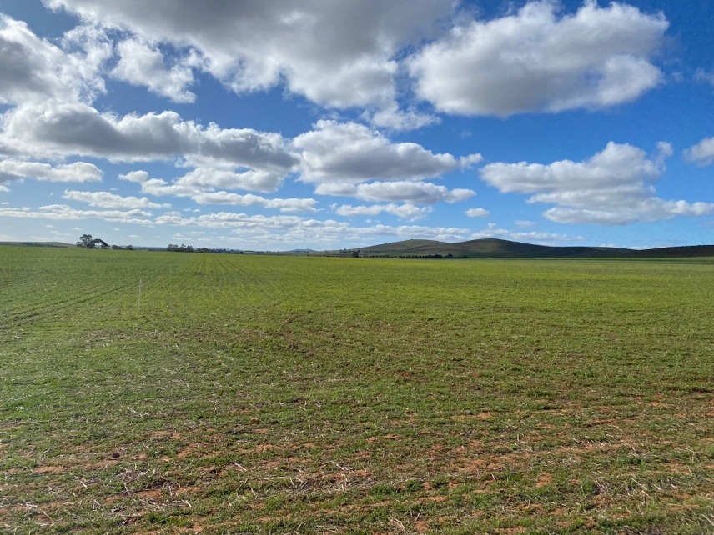
Figure 1: Caltowie North Site. Photo taken August 1.

Sticky Beak Days – Spring 2022

Eastern Sticky Beak Day
The Eastern sticky beak day was held on the 15th of September in the Jamestown area and was ran in conjunction to the Agxtra Field day. The day kicked off mid morning at the syngenta learning centre located at the Jamestown race course. We heard from the team from syngenta and they gave us a run down of the trial there. Syngenta has launched a number of Learning Centres across Australia to showcase new and upcoming crop protection technology and innovation. The Syngenta Learning Centres are a chance for agronomists and farmers to see first-hand the efficacy of a number of products, in some instances before they even hit the market. After some networking with attendees, Beth Humpris presented on the findings from the dryland legume pasture systems project that is located at canowie belt. Lastly, attendees went out to the Caltowie MLA producer demonstration pasture site located at Alison Henderson’s farm. Attendees received an overview of the project and results that have become available for that site.

Northern Sticky Beak Day
The Northern sticky beak day was held the following week on the 20th of September. The afternoon kicked off with a visit to a medic and lucerne varieties trial located at Black Rock. We heard from David Pack & Alan Humphris from SARDI talk about the trial and give expert knowledge and insight into each variety that was planted at this trial site. Next attendees went over to the UNFS canola profitability trial located in Morchard. This site has made a significant comeback with the recent September rains and attendees got to have a good look of at? each of the varieties planted on the day. Lastly, the MLA producer demonstration site located in Pekina was visited, where attendees got a chance to have a nosey at this paddock scale trial and gain some insight into pasture and cropping mixes for grazing.
Upper North Farming Systems would like to thank everyone who was involved in making the crop walks possible and a huge thank you to the landholders that met us at each site and allowed us to have a sticky beak of the trials.
Satellite mapping event report – Spring 2022
On the 18th October, the ‘Using Satellite Imagery for Late Season Crop Management Decisions’ trial site visit was held north of Melrose and Booleroo. This Crop Walk was part of two separate projects – the MLA Pasture Demonstration Site and the SA Drought Hub project ‘Utilising satellite imagery in the growing season to inform adaptive management’.
Site 1 - MLA Producer Demonstration site: Improving Pasture Management Systems
The afternoon kicked off with a visit to one of the MLA funded producer demonstration sites located on Kendrick McCallum’s farm in Melrose. Attendees were given a run through of the trial site, what the aims were of the project and some results that have been seen so far. Jess Koch then gave a run down on the satellite imagery that was available for the site showing the differences between rainfall and also graze events.
Site 2 – David and Chloe Clarke – Booleroo Centre
The second demonstration site was at Perroomba, north west of Booleroo Centre in block called Jacka’s. The purpose of this site was to demonstrate how satellite imagery could be analysed alongside other data layers such as yield data to help create a strategic soil sampling strategy. Using the grower’s knowledge of the field, its management history and the yield limiting factors he has documented, we were able to suggest where to strategically soil core with the intention of using the results to characterise the field into 2-3 management zones for potential variable rate management.
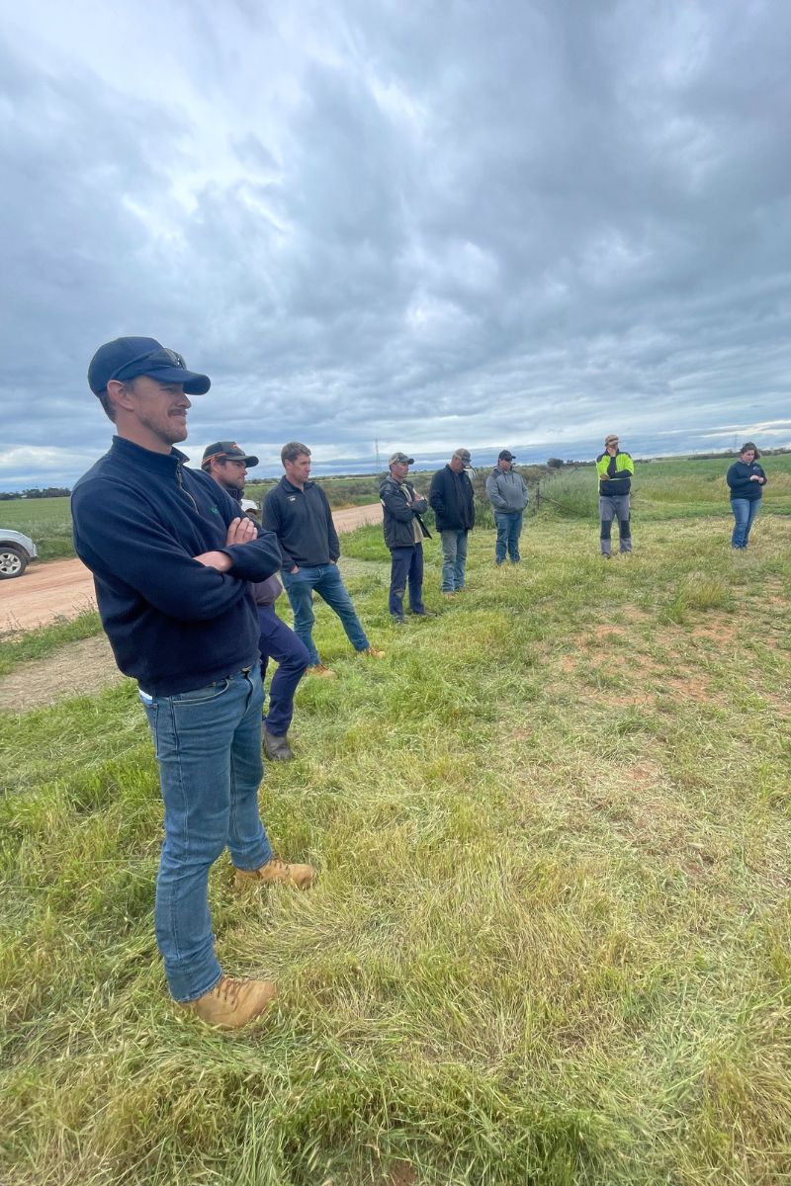
Fig 1 – Above, two different Satamap derived maps, using the RGBI (Soil Colour) and SVI (Satamap Vegetation Index) compared with yield data from 2017 to start looking for correlations.
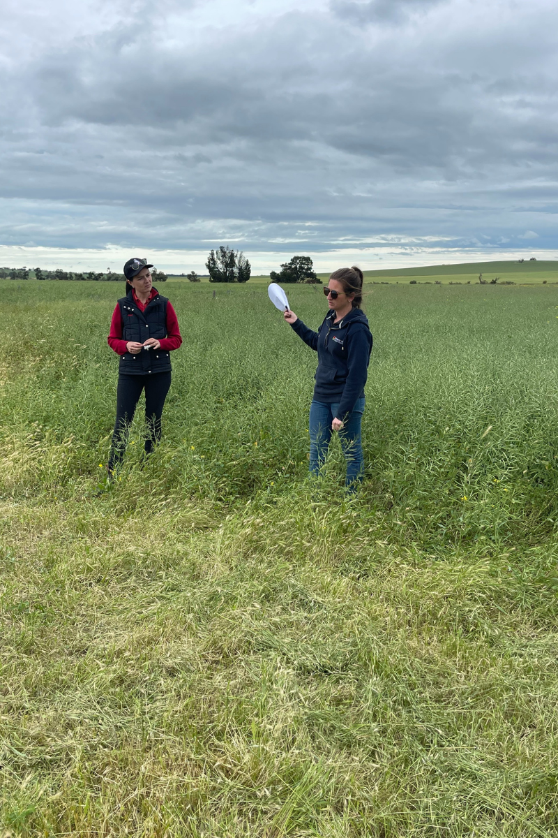
Site 3 – Joe and Jessica Koch – Willowie
The third demonstration site was one of the Firestik Frost Demonstration Site’s. This is one of several sites, sprayed with the product, so we can better understand it’s role in the prevention of frost (and other uses such as pod shatter in canola), through the suppression of ice nucleating bacteria. Michael Eyre’s gave an overview on the chemistry of the product and what we learnt in the trials in the Upper North and further afield in 2021. This field at ‘Jacobs’, Willowie, along with several fields of Todd Orrock’s fields at Murraytown will be assessed through the analysis of plant samples, and the yield and protein data that is collected from the harvesters.
I put together a couple of bits on the PDS visit too if they are helpful: 😊
Breezy Hill Precision Ag Services have been involved in for the Upper North Farming Systems is the 'Pasture Demonstration Site's' as part of an MLA funded trial. Something new for us - our role has been to monitor the pasture growth of mixed species pastures and compare them to a single species pasture, grown side by side in the same field using satellite imagery. Although this project is in its first year (of three), there has already been some interesting results, visible from the sky. At the crop walk we looked at imagery from the Melrose site at Kendrick McCallum’s. This showed that the field sown with a mixed species, compared to the vetch only pasture had greater biomass, and this was evident in the imagery in PCT AgCloud.
Below - an SVI image of the PDS site north of Caltowie, the mixed species is on the right (vetch and barley mix) and the vetch is on the right. Interestingly, the mixed species had the best vigour early on, however in mid September, under moist conditions the vetch took off and as spring progressed is look better than the mixed species.

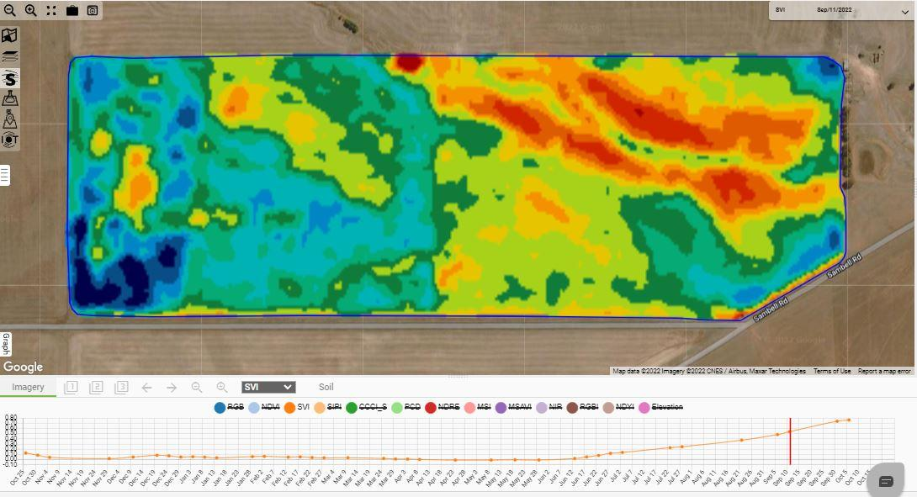

MLA Producer Demonstration Site – Improving Pasture Management Systems - April 2023 Update

Alison Henderson has provided a pasture management site for a second year in a row located at her property at Caltowie North to compare weight gain in sheep grazing single vs mixed species pastures and trial the use of satellite imagery to determine biomass and grazing days left in paddocks.

Alison’s 25-ha paddock was split in half with electric fencing and water troughs. This year’s single species pasture was subzero, a hybrid forage brassica, and the mixed species was subzero, kracken barley and morawa vetch. A mob of 300 ewe hogget’s were used in the demonstration and split in half to graze both pastures and weight gains recorded.

Subzero was sown at a rate of 5kg/ha in the single species trial. For the mixed species pasture, rates were 2kg/ha sub zero, 65kg/ha kracken barley and 45kg/ha vetch. Sheep weight gain in 2023 was slightly higher in the single species pasture grazing last year. Voluntary ryegrass and barley grass helped the single species pasture to resemble a somewhat mixed species pasture and higher sowing rates of sub zero contributed to this pasture having a good balance of protein and energy giving better nutritional value shown in pasture feed test results.

Biomass pasture cuts were sampled to ground truth the satellite imagery which indicated confidence in the estimated Total Standing Dry Matter (TSDM – kg DM/ha). ‘Dry Matter’ refers to the weight of plant material available without water and provides a consistent measure to compare feeds and pasture types across grazing environments or when developing livestock rations.
The satellite imagery has been integrated into Alison’s farm management app which uses the data to estimate Feed on Offer (FOO) in total kg/paddock and generate an estimate of number of grazing days remaining. Alison said the grazing day estimate was comparable to her visual observations through spring and she can see the value of using this technology in the future as another tool for grazing decision making on farm through the season.

A field day will be held in spring 2024 at Alison’s property to wrap up results of this PDS project and learn more about Improving Pasture Management Systems in the Upper North. This Producer Demonstration Site is funded by Meat & Livestock Australia.
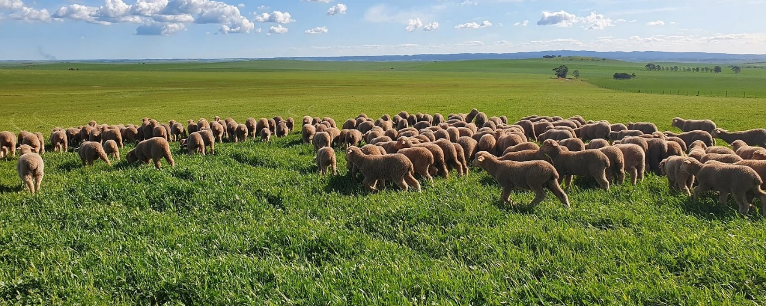
Photo: Henderson’s ewe hoggets grazing the trial.
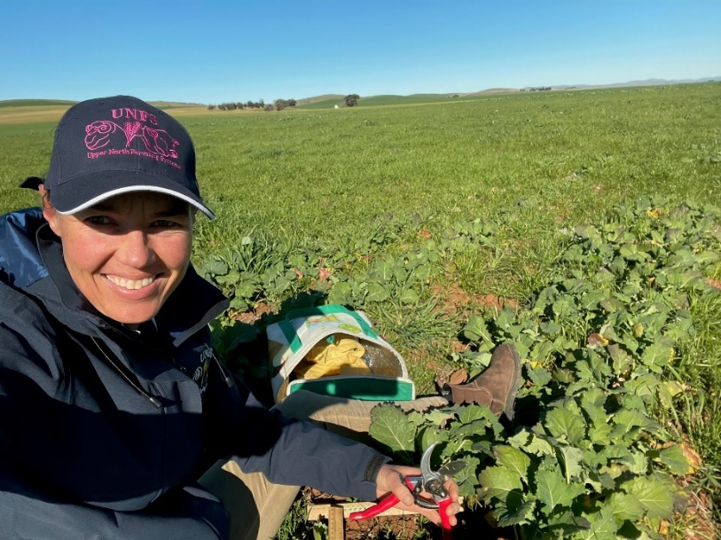
Photo: Rachel Trengove sampling pasture biomass cuts for ground truthing satellite imagery of the pasture paddocks
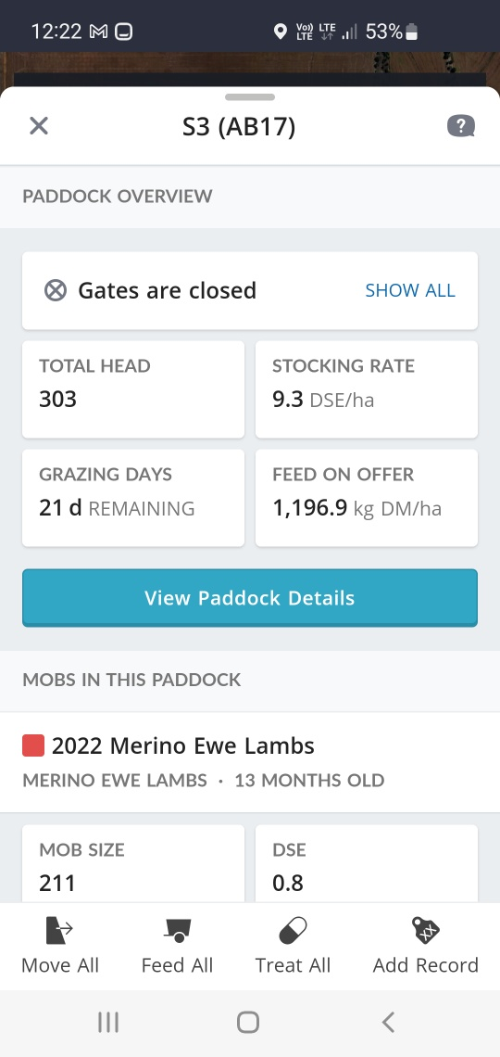
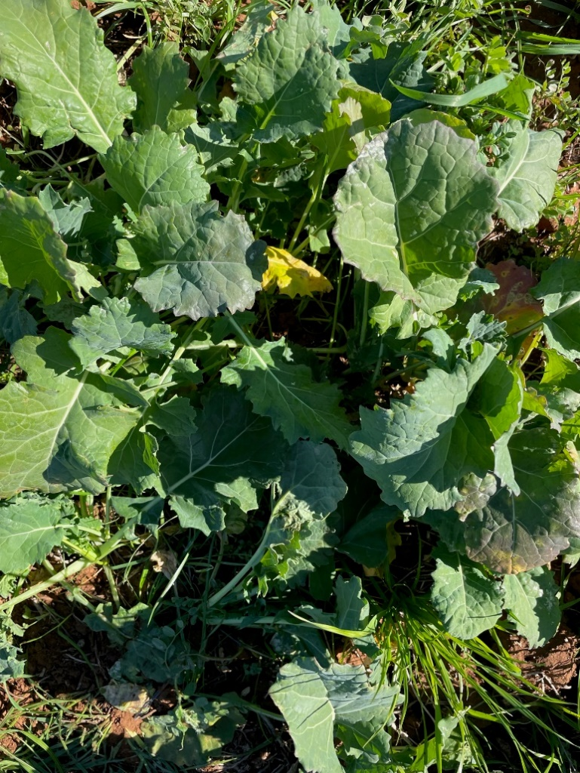
Photo: Sub zero (Brassica napus) included in this years trial pastures
Photo: Farm management App – example of estimate of grazing days remaining for the trial paddock

UNFS / MLA Producer Demonstration Site – Improving Pasture Management Systems September 2025 Update
The Upper North Farming Systems (UNFS) MLA Producer Demonstration Site (PDS) on Improving Pasture Management Systems is entering its fourth and final year. Alison Henderson has once again provided a trial site at her property in Caltowie North to compare sheep weight gains on single vs. mixed species pastures, while also trialling the use of satellite imagery to estimate pasture biomass and grazing potential.
Originally planned as a three-year project, the trial was extended after last year’s pasture failed to germinate as a result of drought conditions in our region. This year, Alison has dedicated a 25-hectare paddock, split into two equal areas with electric fencing and a water trough.
- Single species treatment: barley sown at 75 kg/ha
- Mixed species treatment: subzero (3 kg/ha), barley (70 kg/ha) and morawa vetch (35 kg/ha)
Her sheep flock will be split evenly to graze both pastures, with weight gain measured across both mobs before and after the treatments are grazed.
To complement livestock data, satellite imagery will be captured at three points through the season:
- Just prior to grazing
- Immediately post-grazing
- One month post-grazing (to assess recovery)
This imagery will estimate Total Standing Dry Matter (TSDM, kg DM/ha), which is a consistent measure of feed available. Pasture cuts will be taken early next week to ground-truth the imagery, using the CiboLabs Survey 123 App to sample 10 points diagonally across the paddock. Feed test samples will also be collected to compare the nutritional quality of the single and mixed pastures.
Upcoming Workshop
To share the findings and explore pasture management strategies for the Upper North, UNFS will host a workshop on Tuesday, 23rd September at Alison’s property. We are excited to welcome Cam Nicolson as guest speaker, bringing his extensive experience and insights to our region.
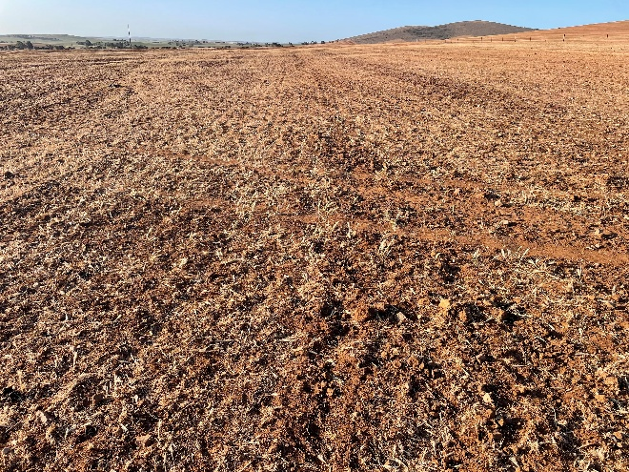
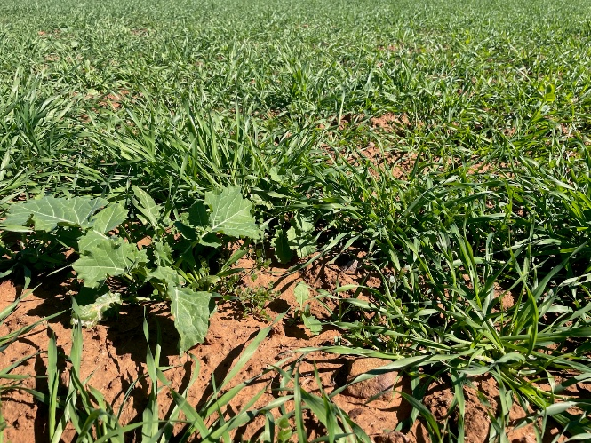
This PDS project has been funded by Meat & Livestock Australia
Photo: Mixed species pasture in August 2024 under drought conditions
Photo: Mixed species pasture August 2025
Pasture Workshop Newsletter Article – December 2025
In September, farmers joined Cam Nicholson, alongside local producers Alison Henderson and Andrew Cootes, for a practical workshop supporting the current MLA PDS project with UNFS. The project finishes this year and aims to improve pasture management in the Upper North by demonstrating better pasture options and showing how understanding Food On Offer, feed budgeting and the use of remote-sensing tools can lift livestock productivity.
Alison, who is hosting one of the PDS demonstration sites, compared mixed versus single-species pastures. She is exploring the use of mixed pastures, rotational grazing and containment feeding when needed to achieve greater soil cover and maintain sheep condition year-round.
Andrew’s participation in a Grazing for Profit course and involvement with the Mid North Grasslands Group influenced his decision to trial an intensive rotational grazing system. He originally subdivided his non-arable hills country into small 4–5 ha paddocks, but over time it became clear that sheep consistently grazed out the north and west slopes first—highlighting the importance of aspect and the need to adjust fence lines. Several fences have since been moved. To achieve effective cell grazing, he has found he needs around 200 DSE stocking density with long rest periods—essentially exclusion for most of the year. While higher stocking rates haven’t been achieved yet for Andrew, the system has delivered better groundcover and a lift in higher-quality native grasses, rather than low-value species such as geranium and nutgrass which tend to dominate under set-stocking. However, the past two very low-rainfall years have pushed the whole system backwards despite good management.
Cam’s Key Messages
Pasture Growth
Fertiliser is hugely important for pasture production, but to get maximum value from nutrients, leaf management is critical. As Cam explains, “fertiliser grows fat leaves, not fast leaves.” Leaf emergence is driven by soil and temperature, while leaf “fatness” depends on nutrient availability. Grazing management is also vital to allow plants time to grow adequate leaf area between grazing’s. “You are wasting your time if you don’t let the leaves grow.”
He emphasised the importance of soil testing, given fertiliser is often the biggest cost and can be the limiting factor in pasture productivity. “Designing an optimal grazing system relies on understanding patterns of growth of different species.”
Cam noted that the variability or range of pasture growth from year to year is more useful for management decisions than long-term averages: “We need to understand the system we have to set up to manage variability - Get the daily pasture growth rate graph, then build the system around it.”
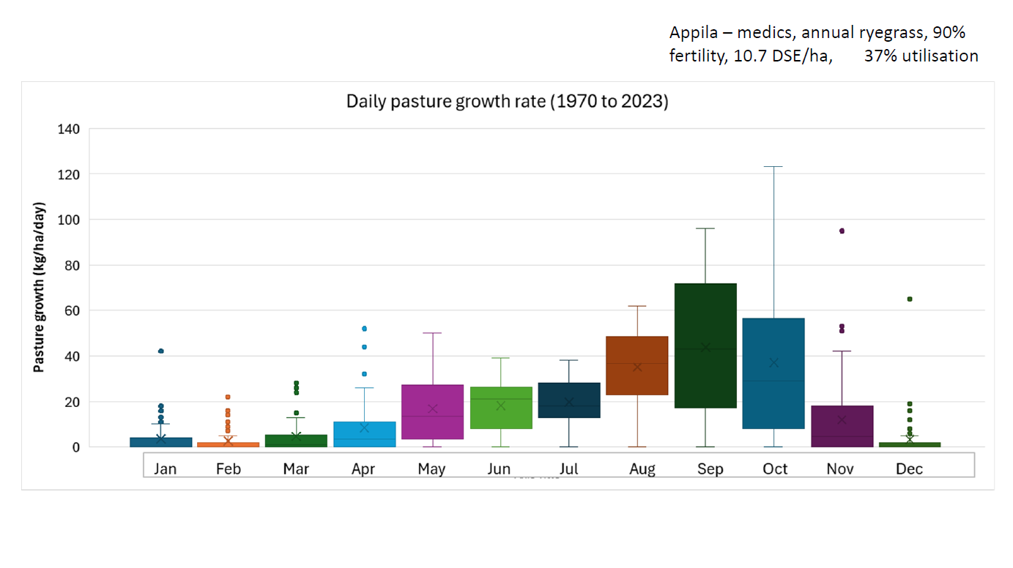
Figure 1. Daily pasture growth rate graph for Appila showing variability.
Grazing Stubbles
Stubbles can play an important role in filling a feed gap in mixed farming systems, but their grazing value has declined due to improved weed control and modern header setups. Cam encouraged growers to assess paddocks before grazing: sheep perform well while grain and green pick (such as crop regrowth and weeds) remain, but once these disappear, livestock quickly lose condition.
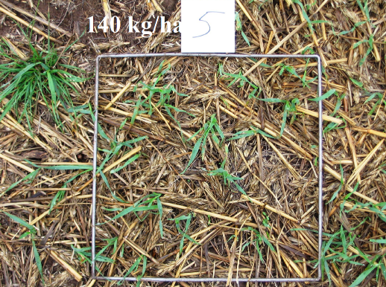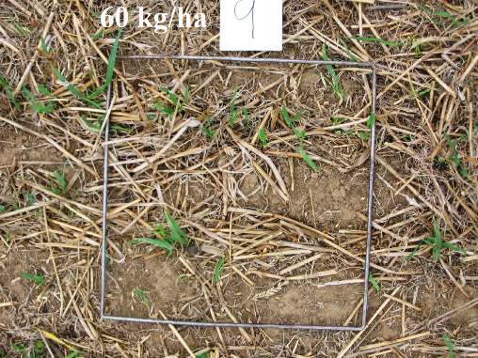
Photos – stubble feed on offer estimates
Grazing Crops
Cam sees significant potential for grazing crops—intended to be taken through to grain—in selected paddocks in the Upper North. “It’s another piece in the whole farm supply of feed year-round.” Grazing crops can also delay crop maturity by 7–10 days, helping shift flowering out of frost-risk periods. Consistent grazing across all plants is essential; uneven grazing leads to uneven maturity, creating harvest challenges.
Cam noted the need to apply an additional 20–30 kg nitrogen to replace removed biomass. He also highlighted examples from WA where large mobs graze crops for 7–10 days before rotating, supported by staggered sowing dates. While not suited to every paddock, Cam sees real opportunity in grazing crops in this region strategically, allocating paddocks with matched sowing dates and winter varieties.
Summary Quotes from Cam
“We really need to think about the whole farming system – it’s a very complicated system.”
“We manage risk as farmers, so it’s really important to understand the volatility and ignore the averages for good decision-making.”
“We are constantly compromising certain parts of a grazing system, but the art of a good grazing system is minimising the compromise to maximise production—there are a lot of moving parts.”

